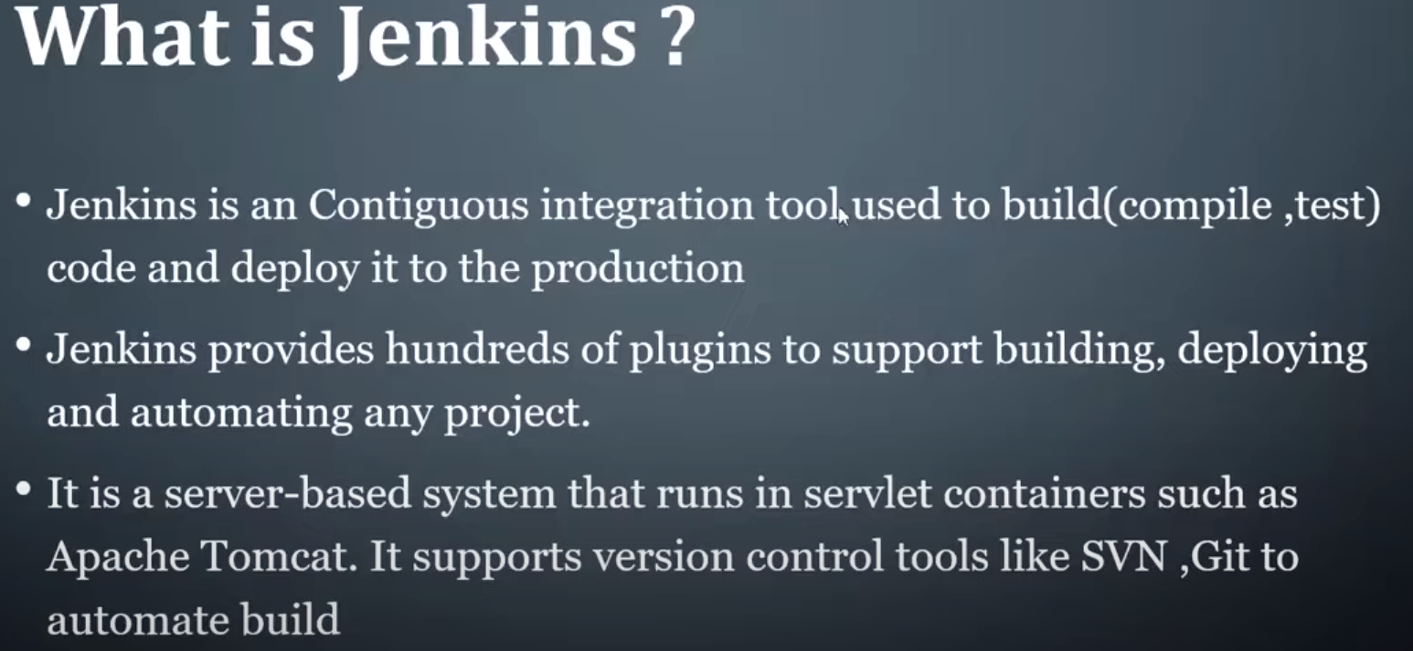

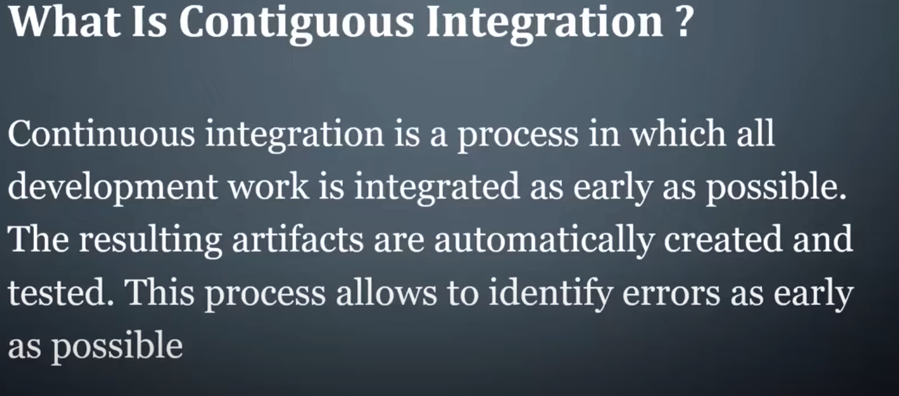

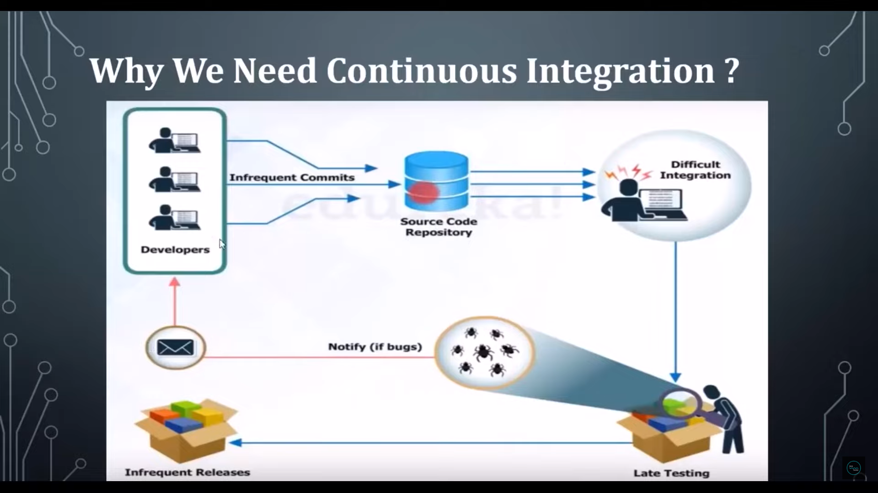

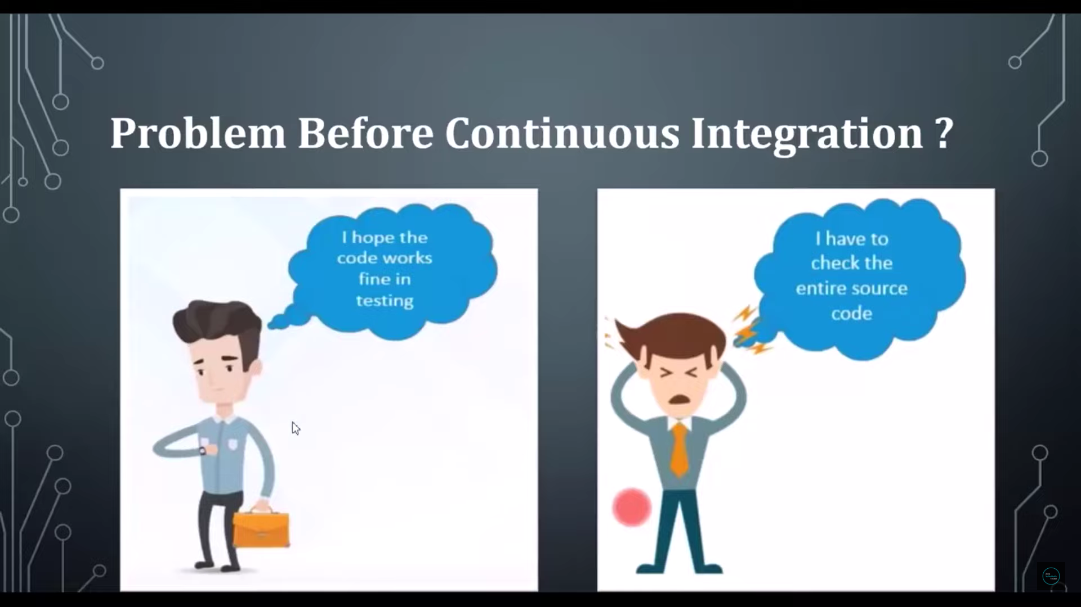

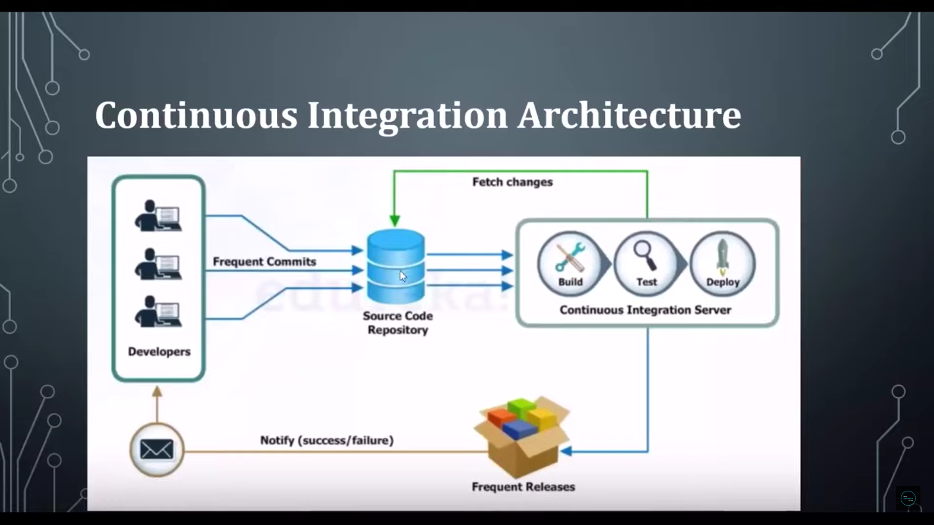

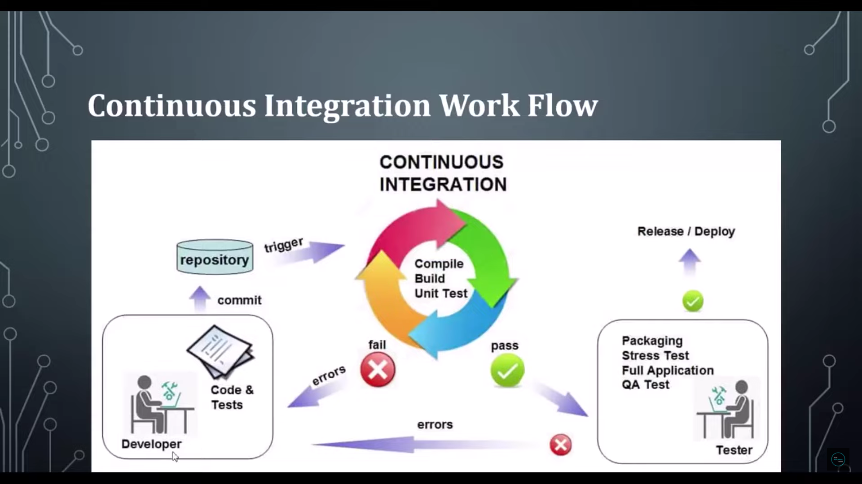

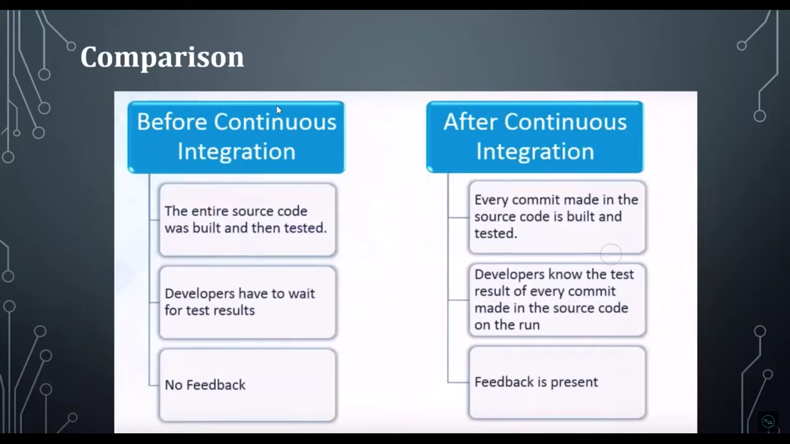

How to install Jenkins Server:

Open this link

<https://www.jenkins.io>

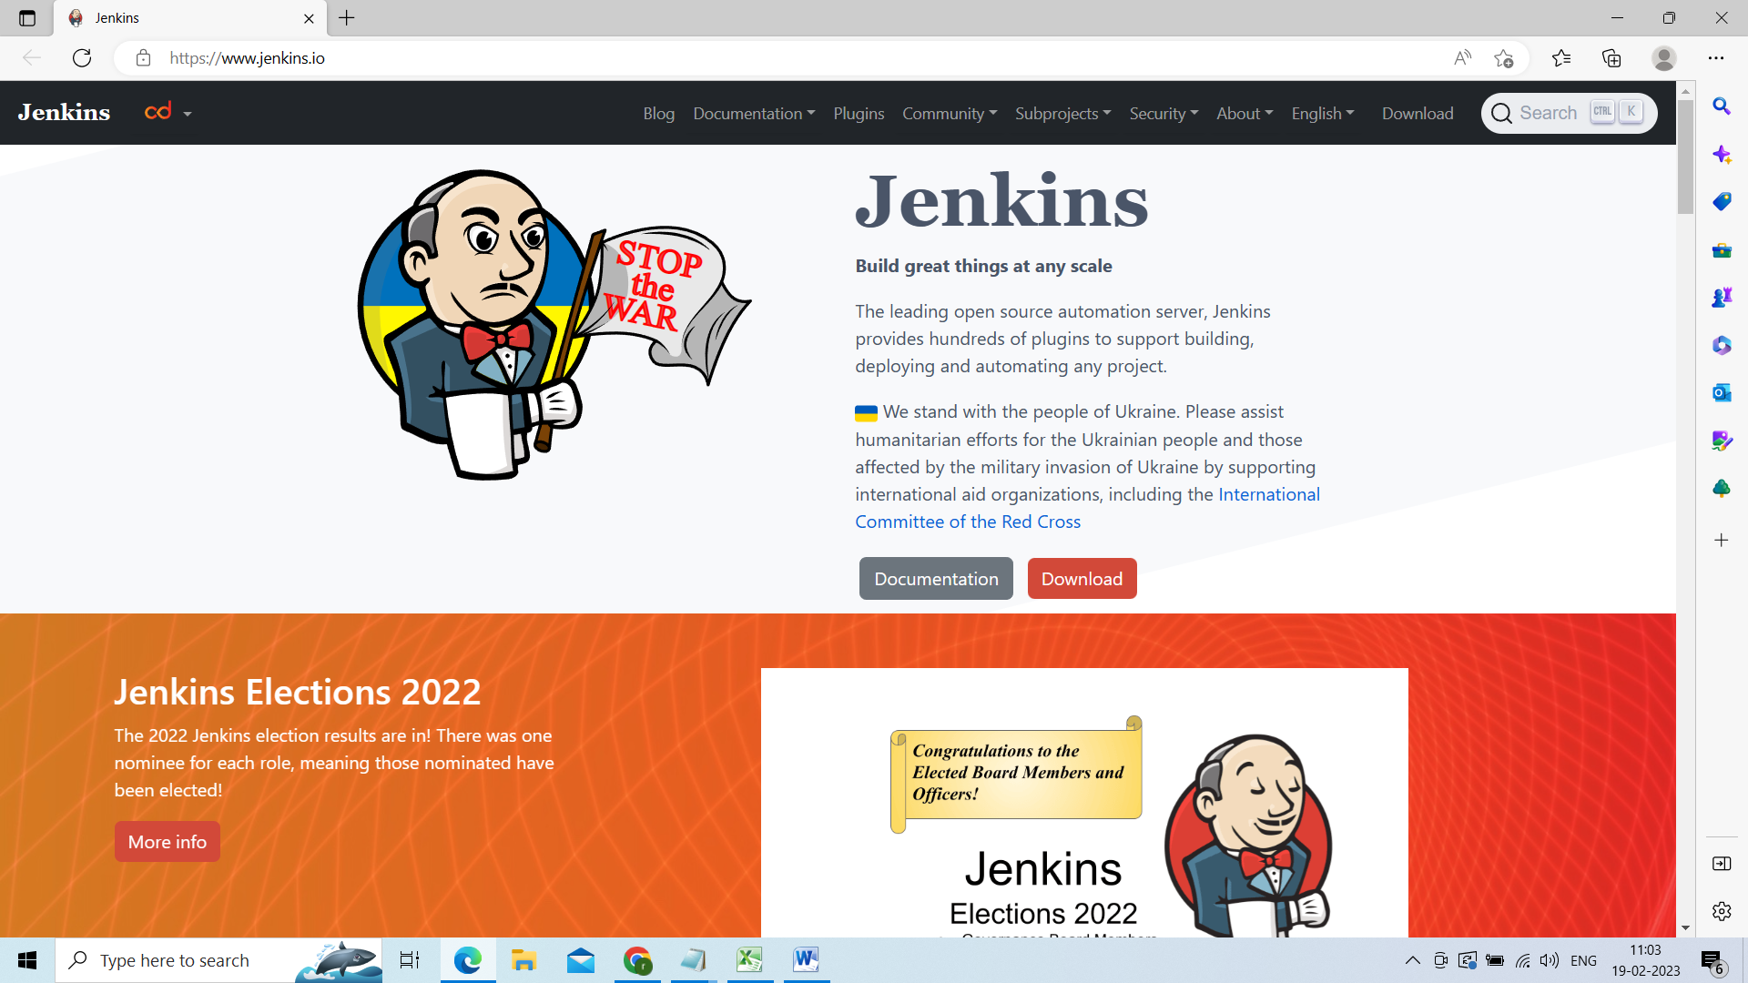

Now click on download and depends on java version u need to download the Jenkins server

Under LTS click on past releases

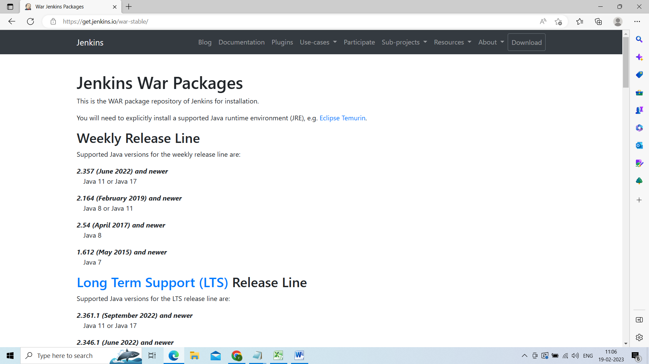

Am using java 11 version so am using **Download Jenkins 2.375.3 LTS for:**

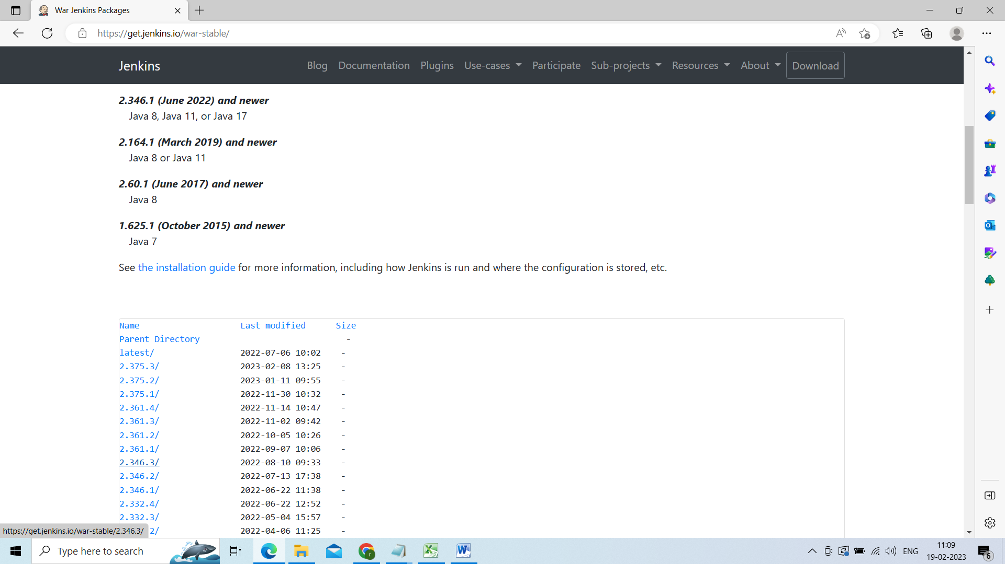

Select the war file

Click on generic java package

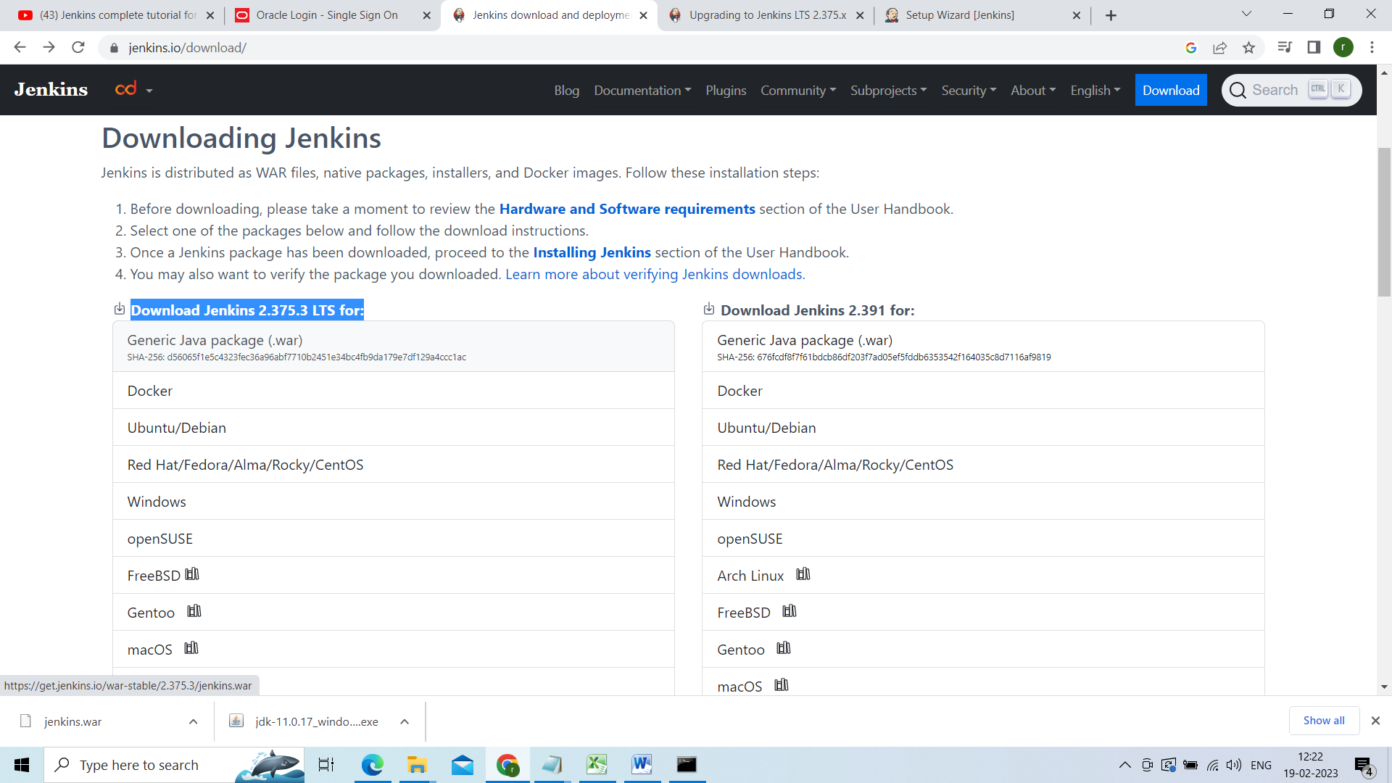

Now go to that Jenkins.war folder open the cmd from that folder

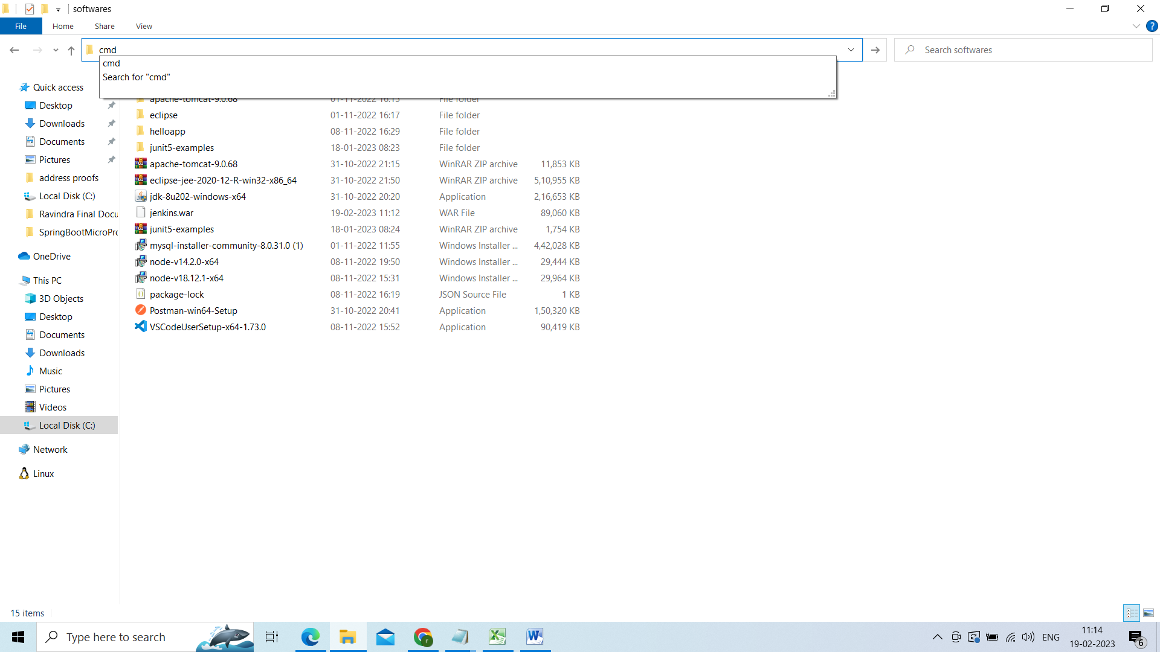

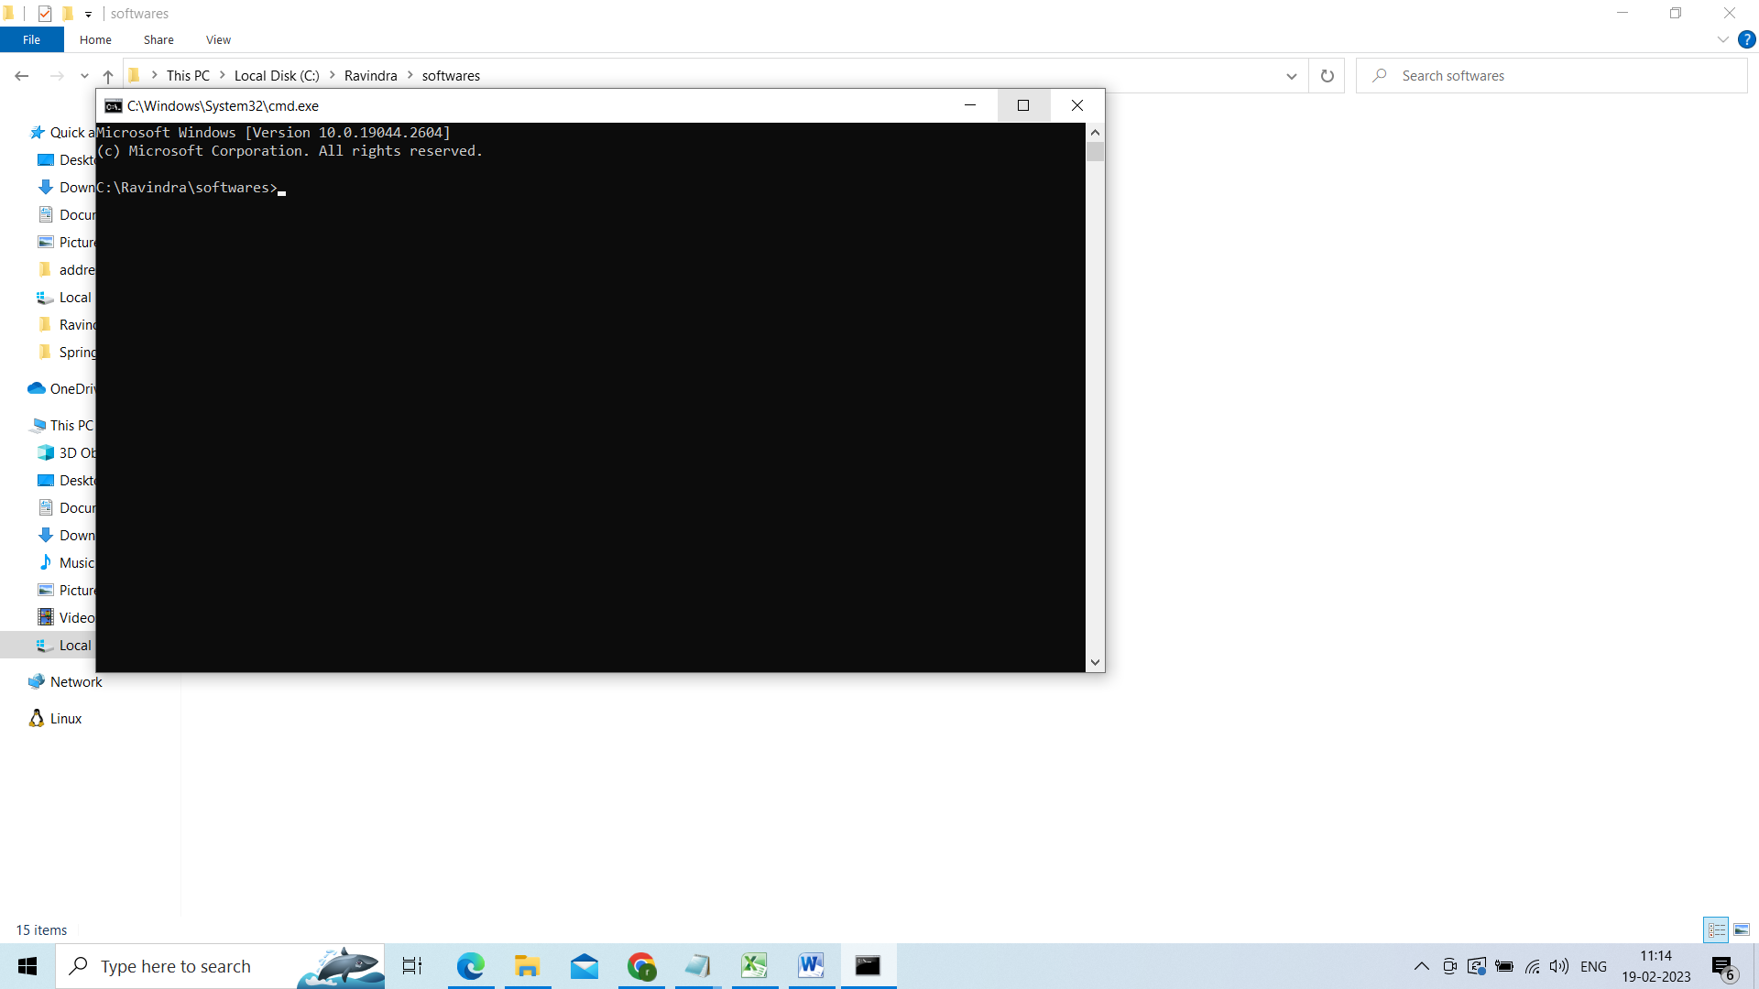

And execute the java –jar Jenkins.war

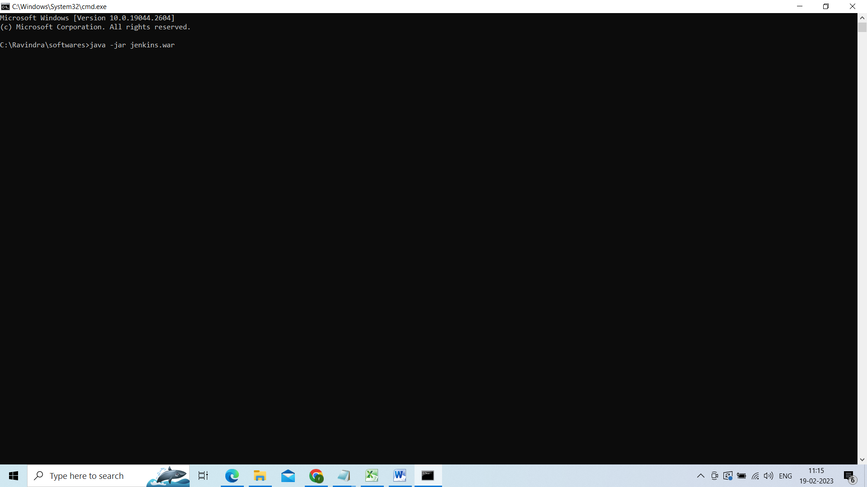

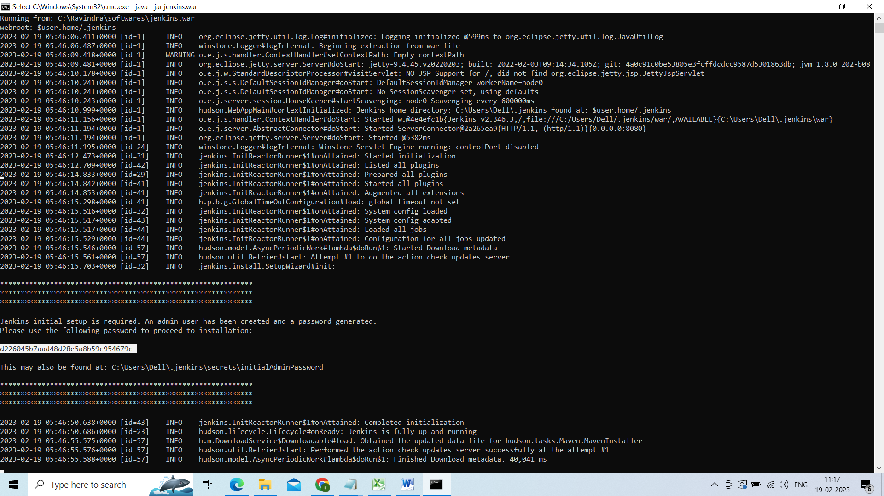

Highleted one is initial password

d226045b7aad48d28e5a8b59c954679c

u have to use this password to login

now open the browser by default it will run one the port number 8080

<http://localhost:8080>

it will ask for admin password u need to give initial password

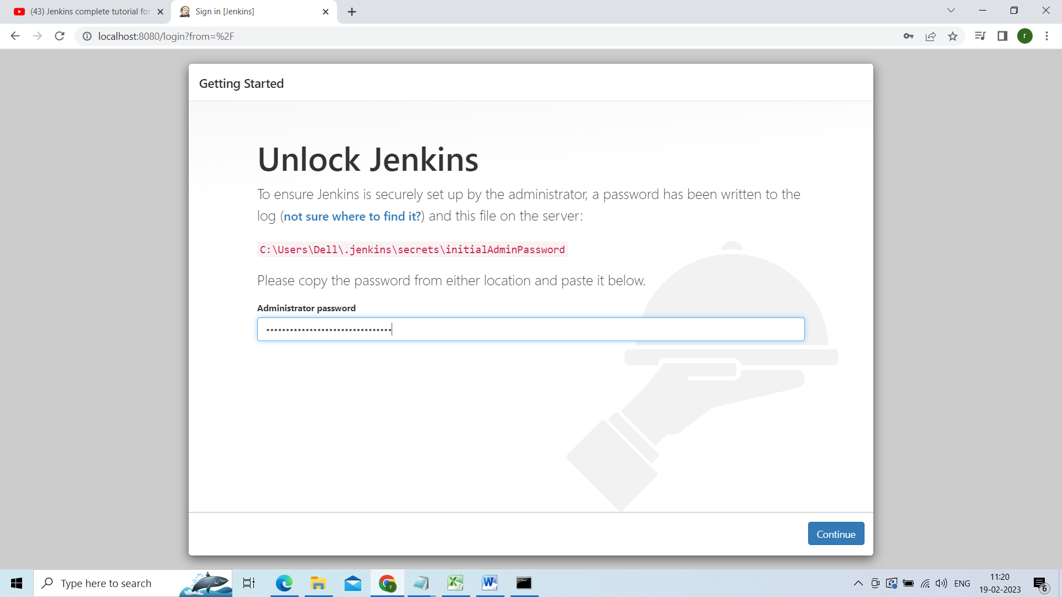

Click on install suggested plug ins

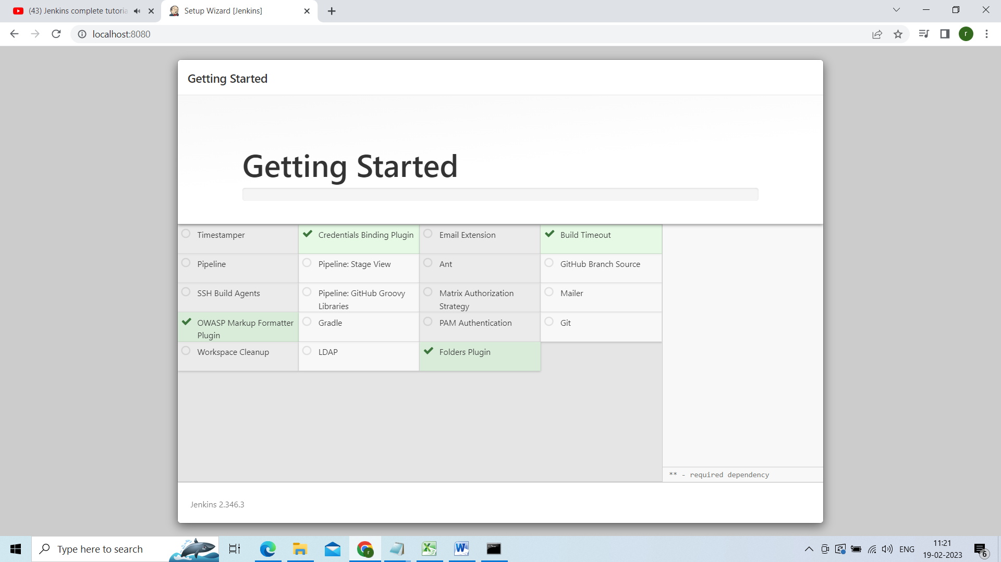

If any plugins failed to install just click on retry.

After installation of u have to fill the below details

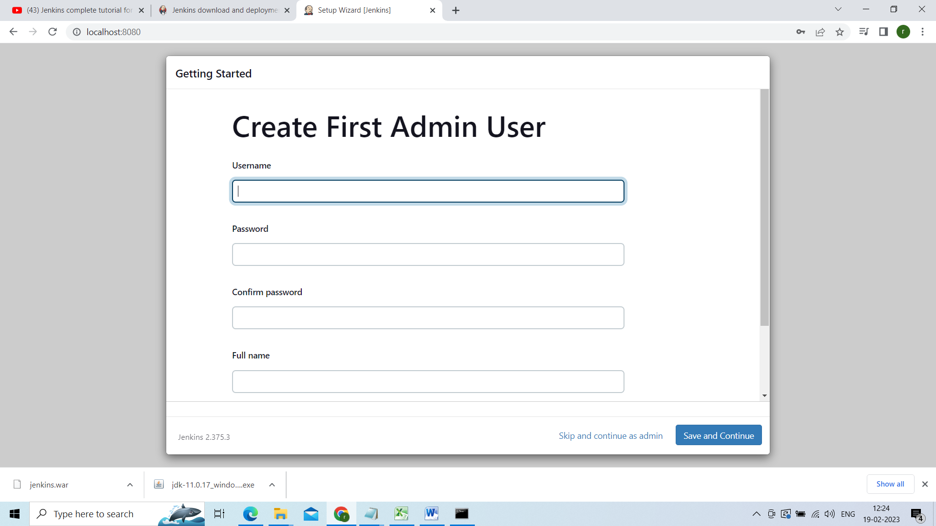

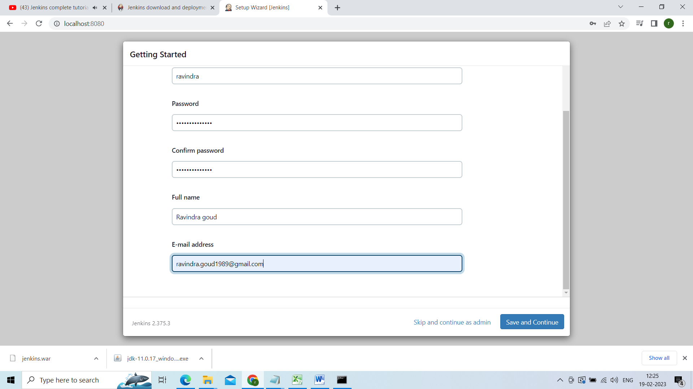

Now save and continue

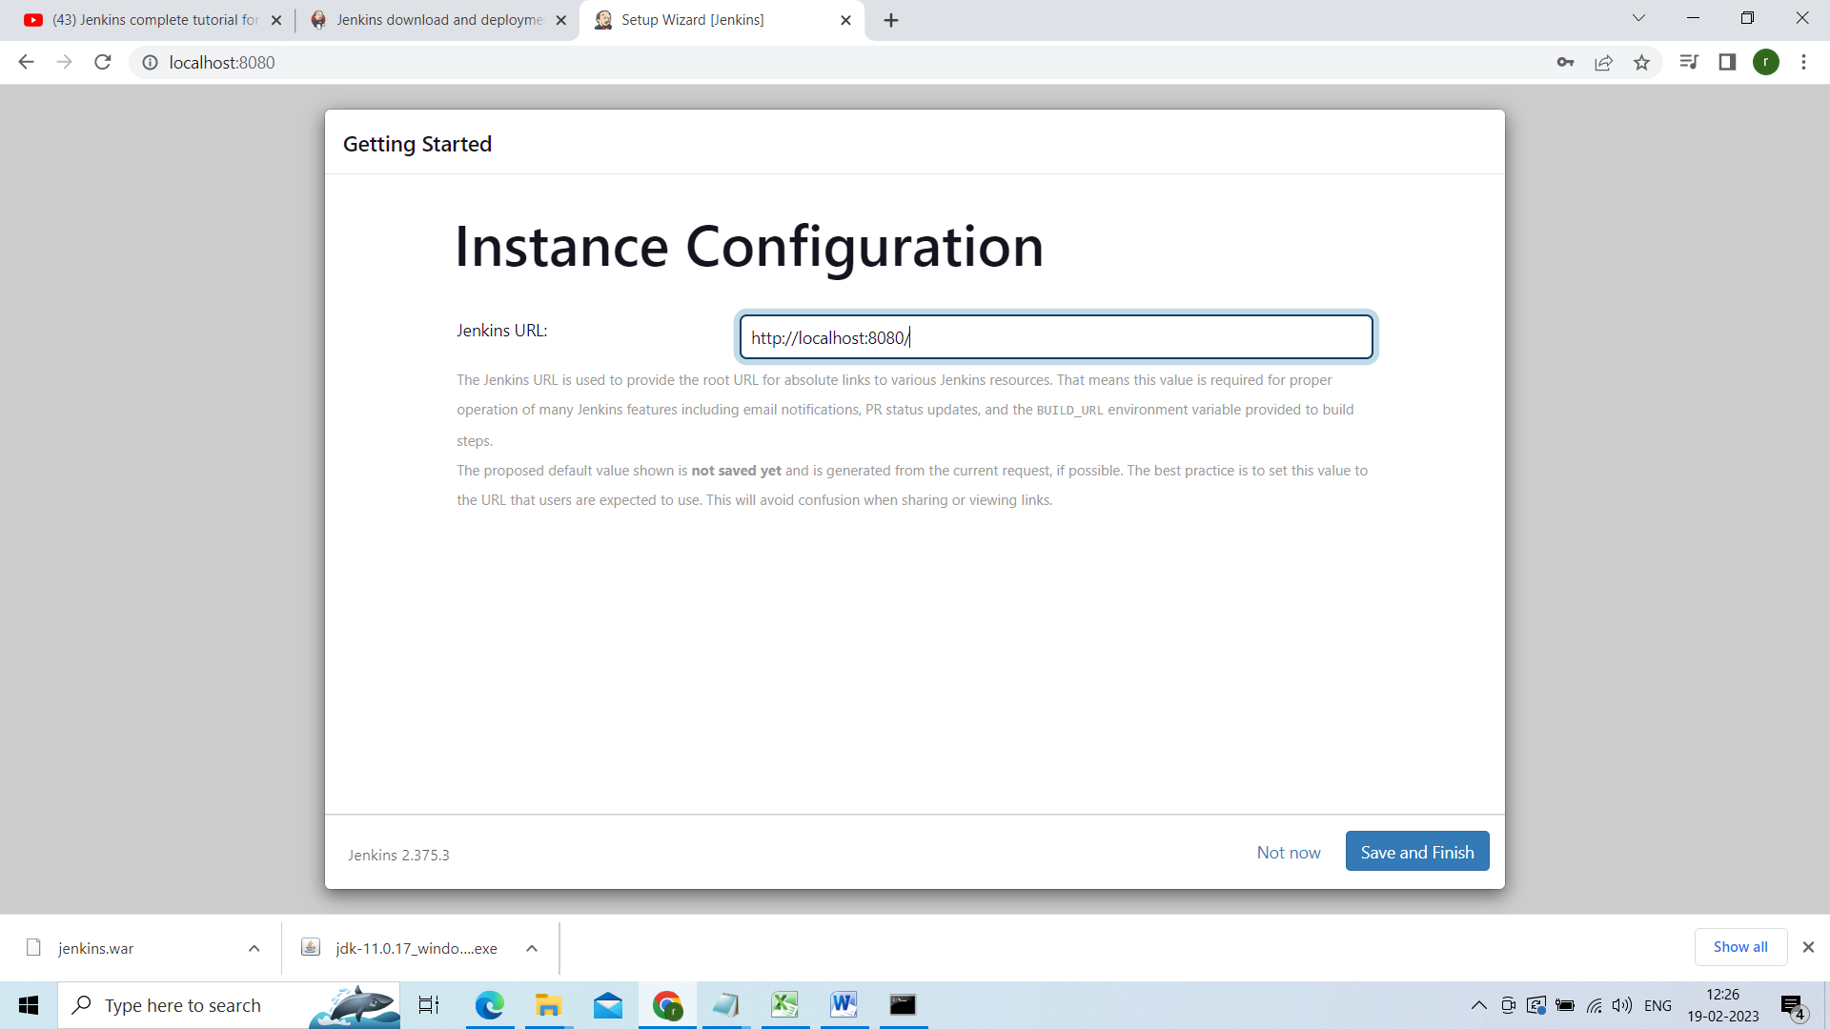

Save and finish

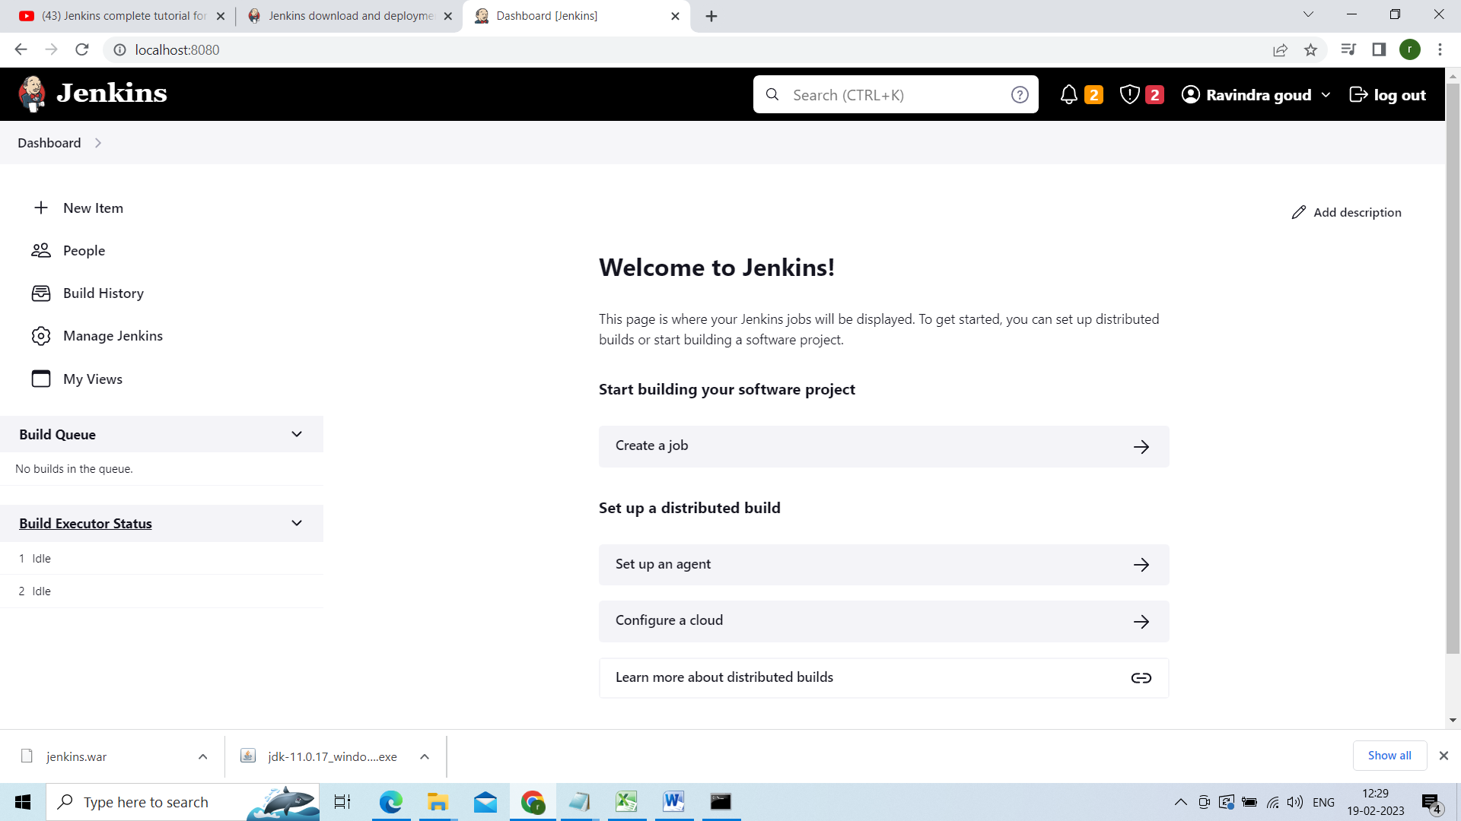

Jenkins dashboard

Going to integrate our github code to Jenkins so that we are going to check that how the build will be triggered

First create the project in eclipse have created the project in eclipse and kept in the below git just u have to download and import into eclipse

Project github link

<https://github.com/goud89105/ravindra>

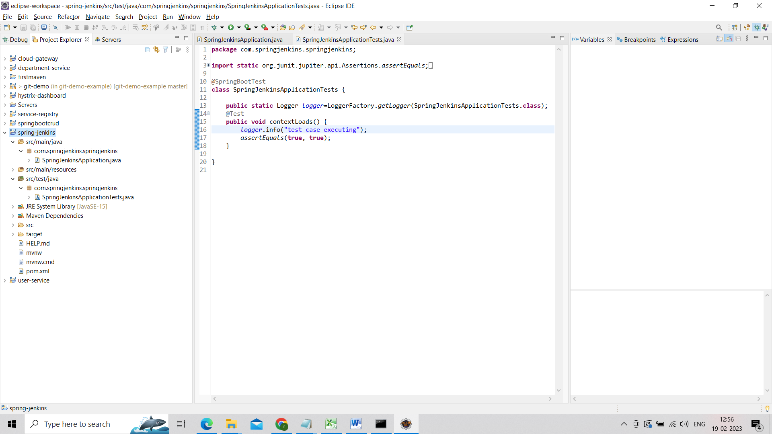

Now lets create the Repository in github and we will sync our project to that repository.

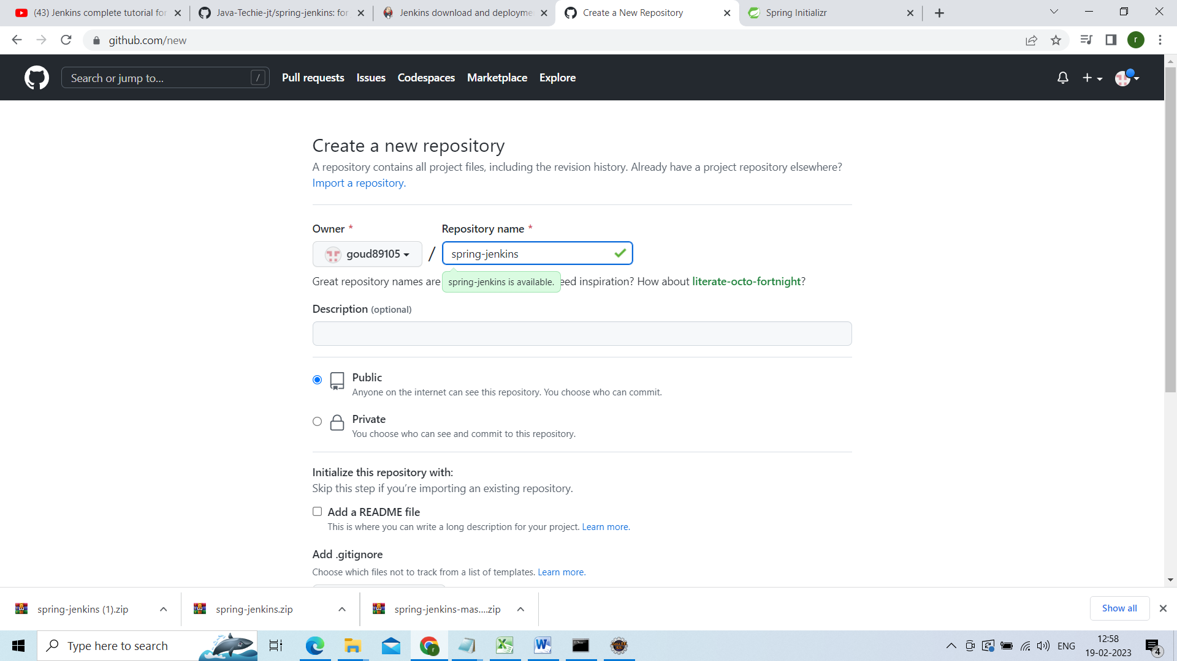

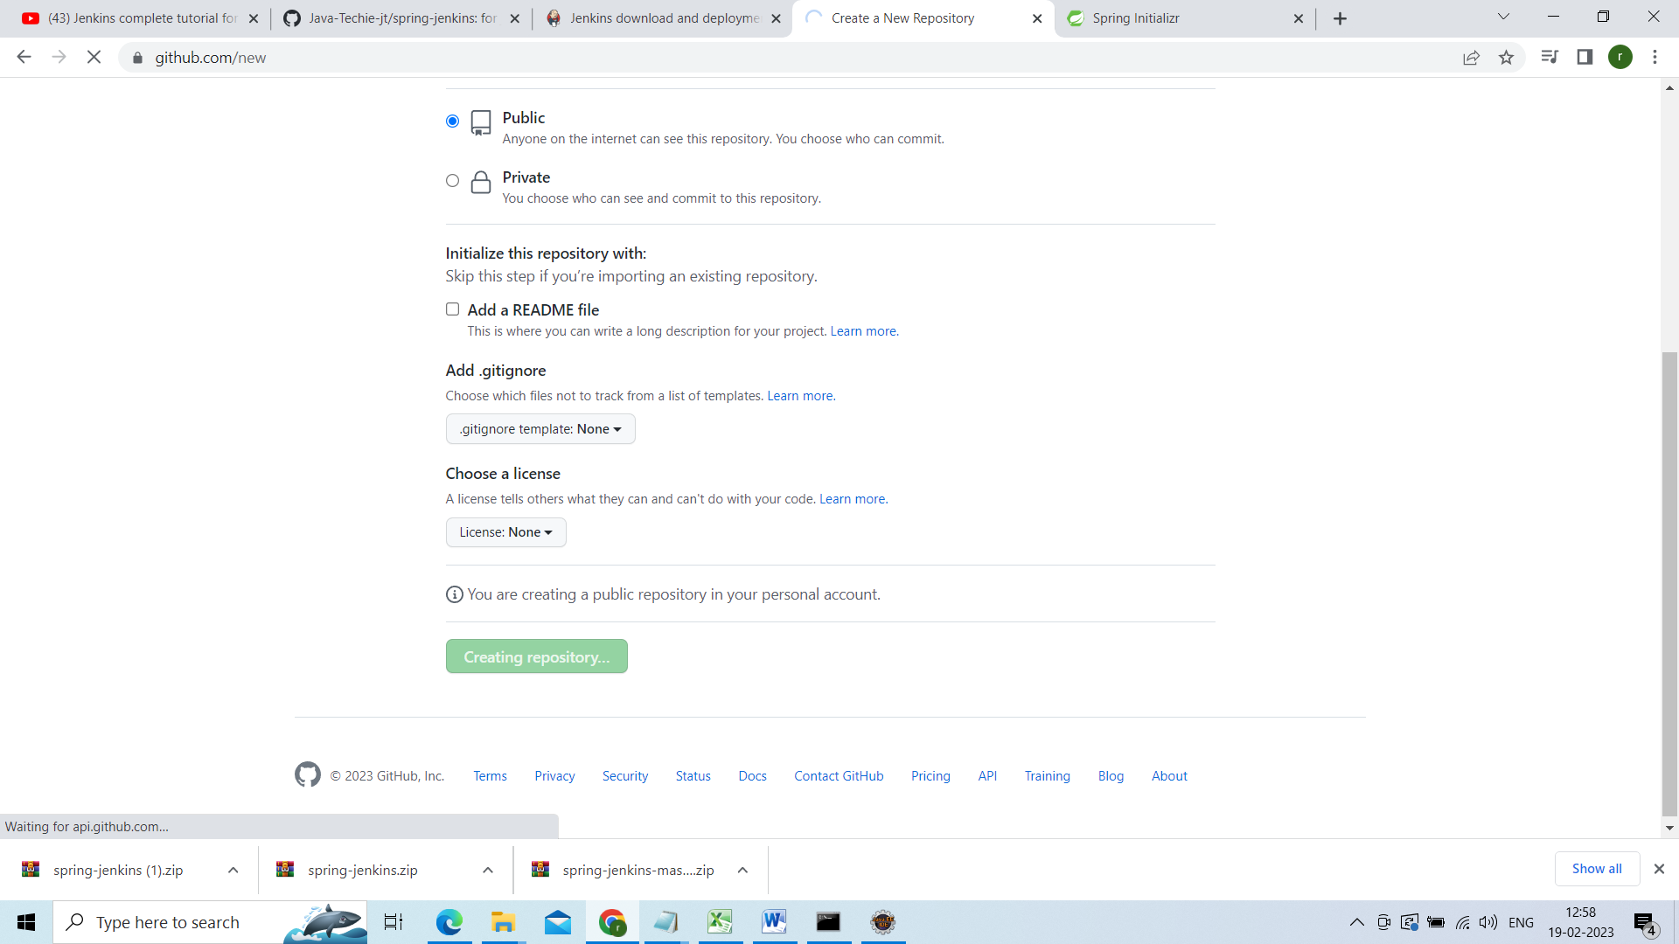

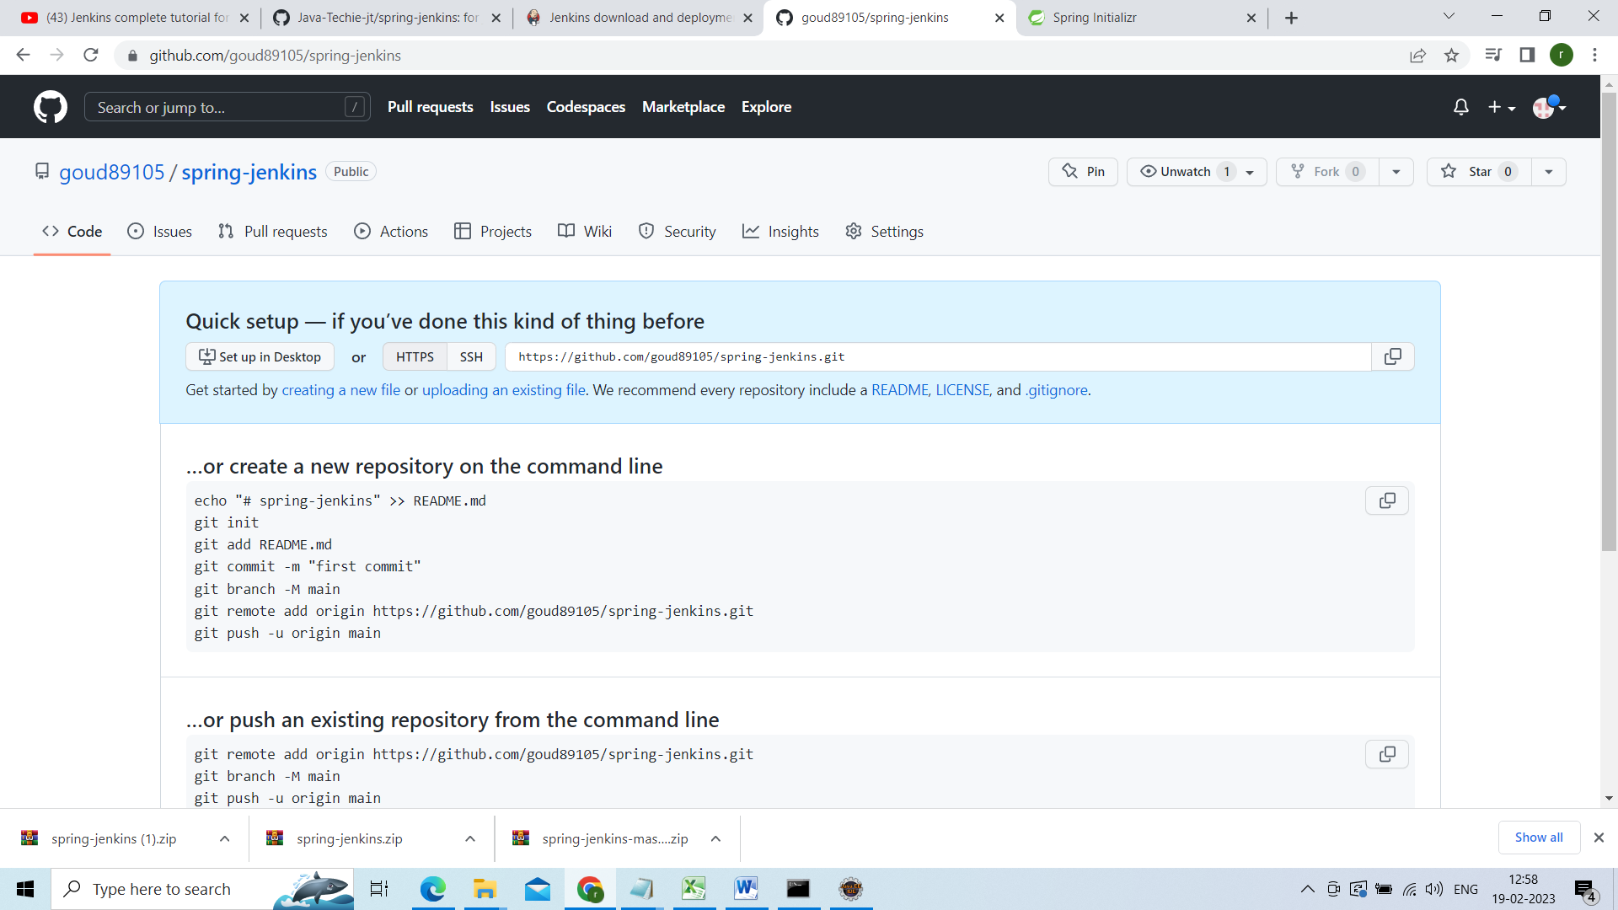

Now will sync our application to this repository

Go to the project directory

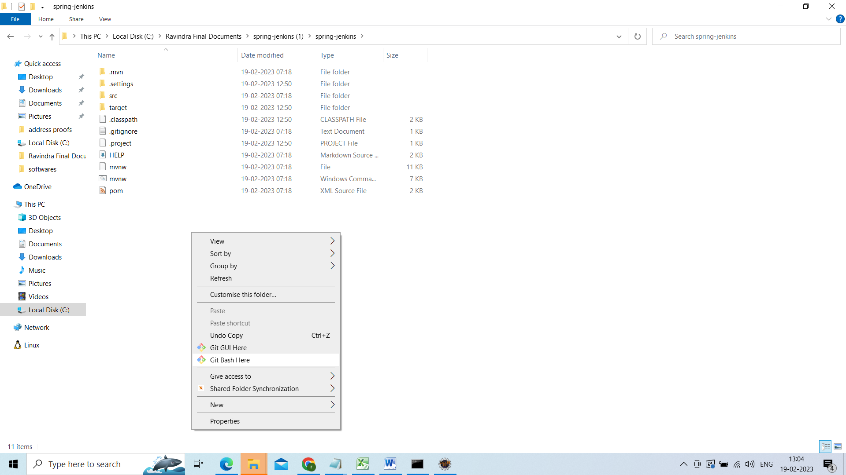

Do git bash here

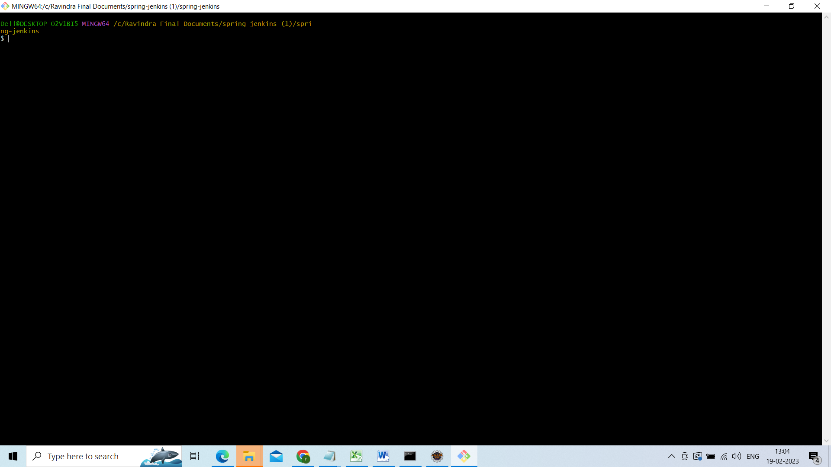

Initialize this repository

Git init

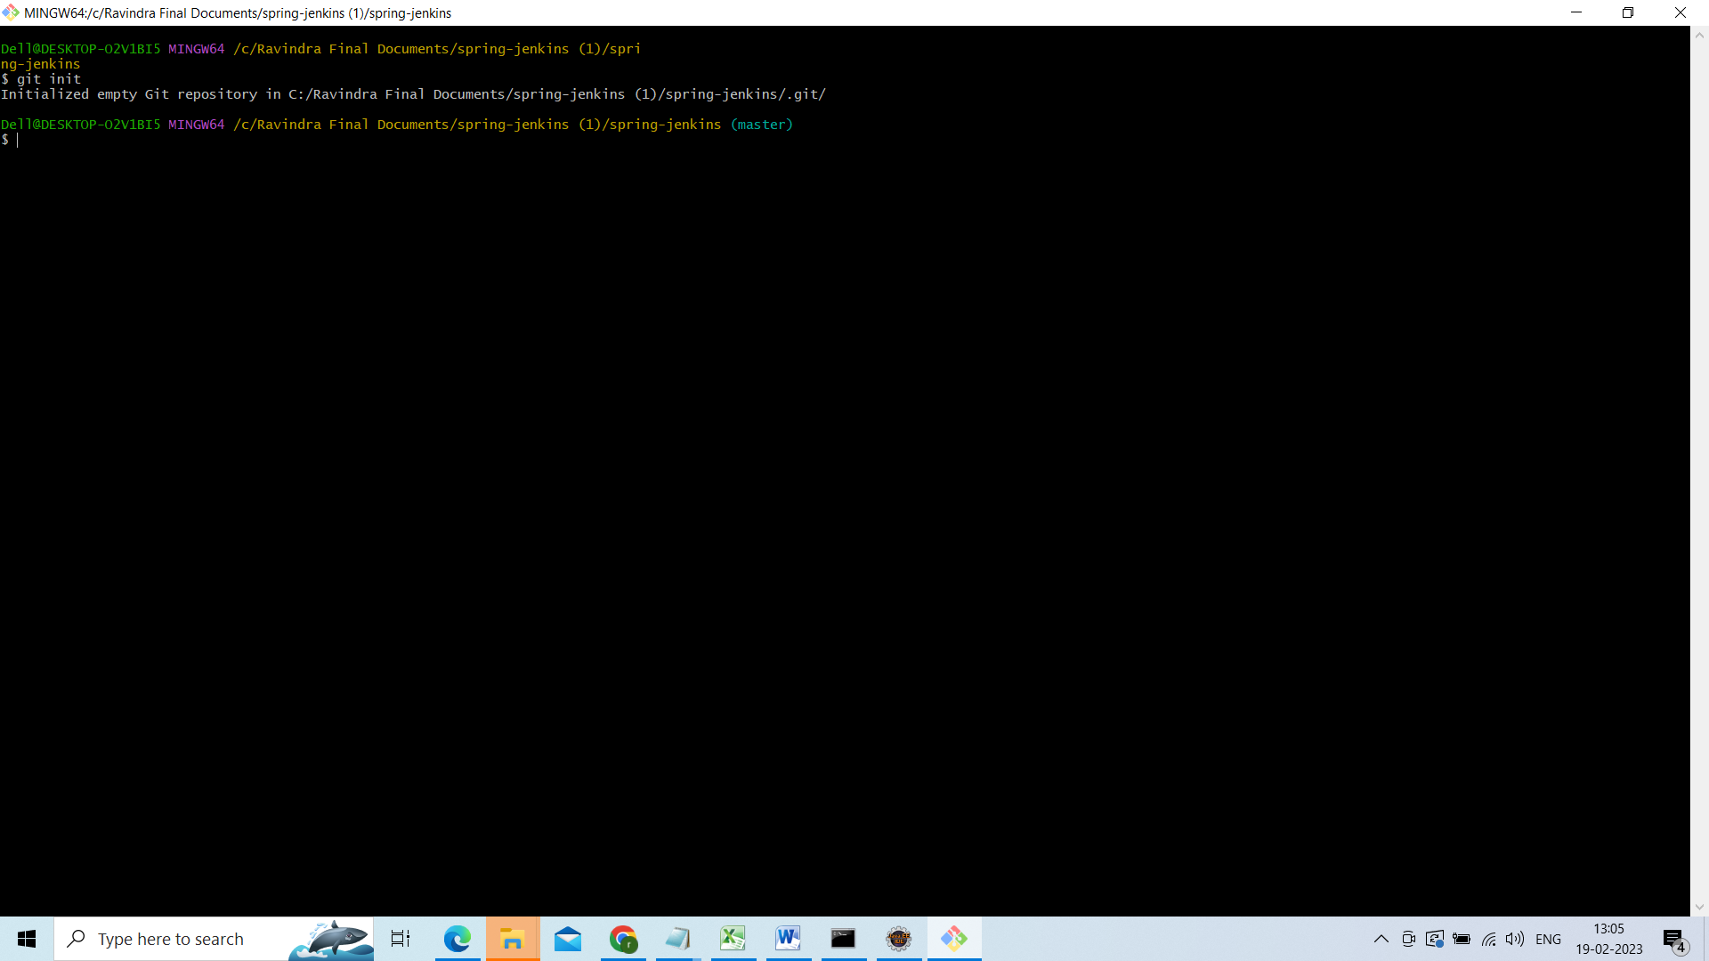

Then check the status

Git status

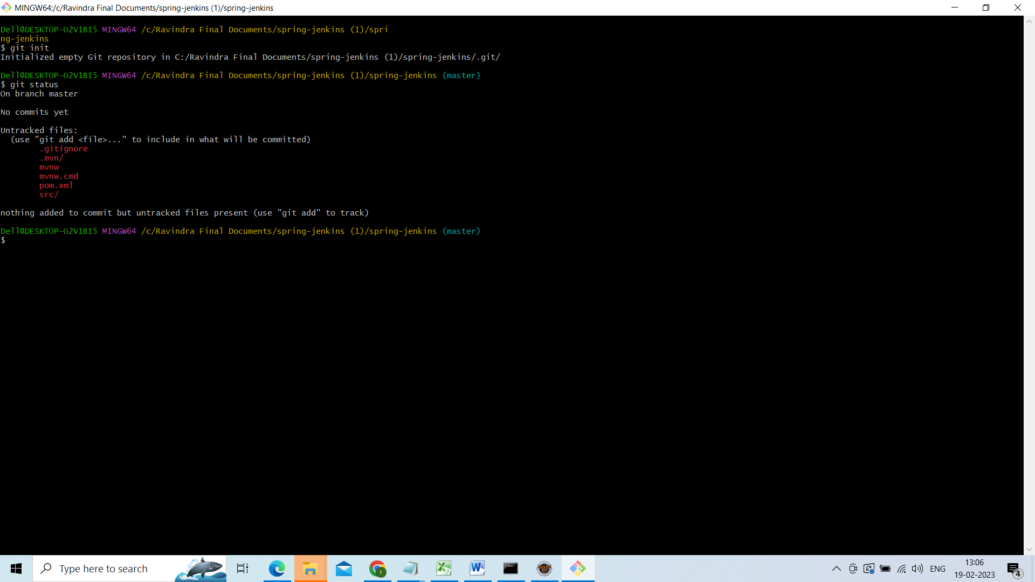

Git add .

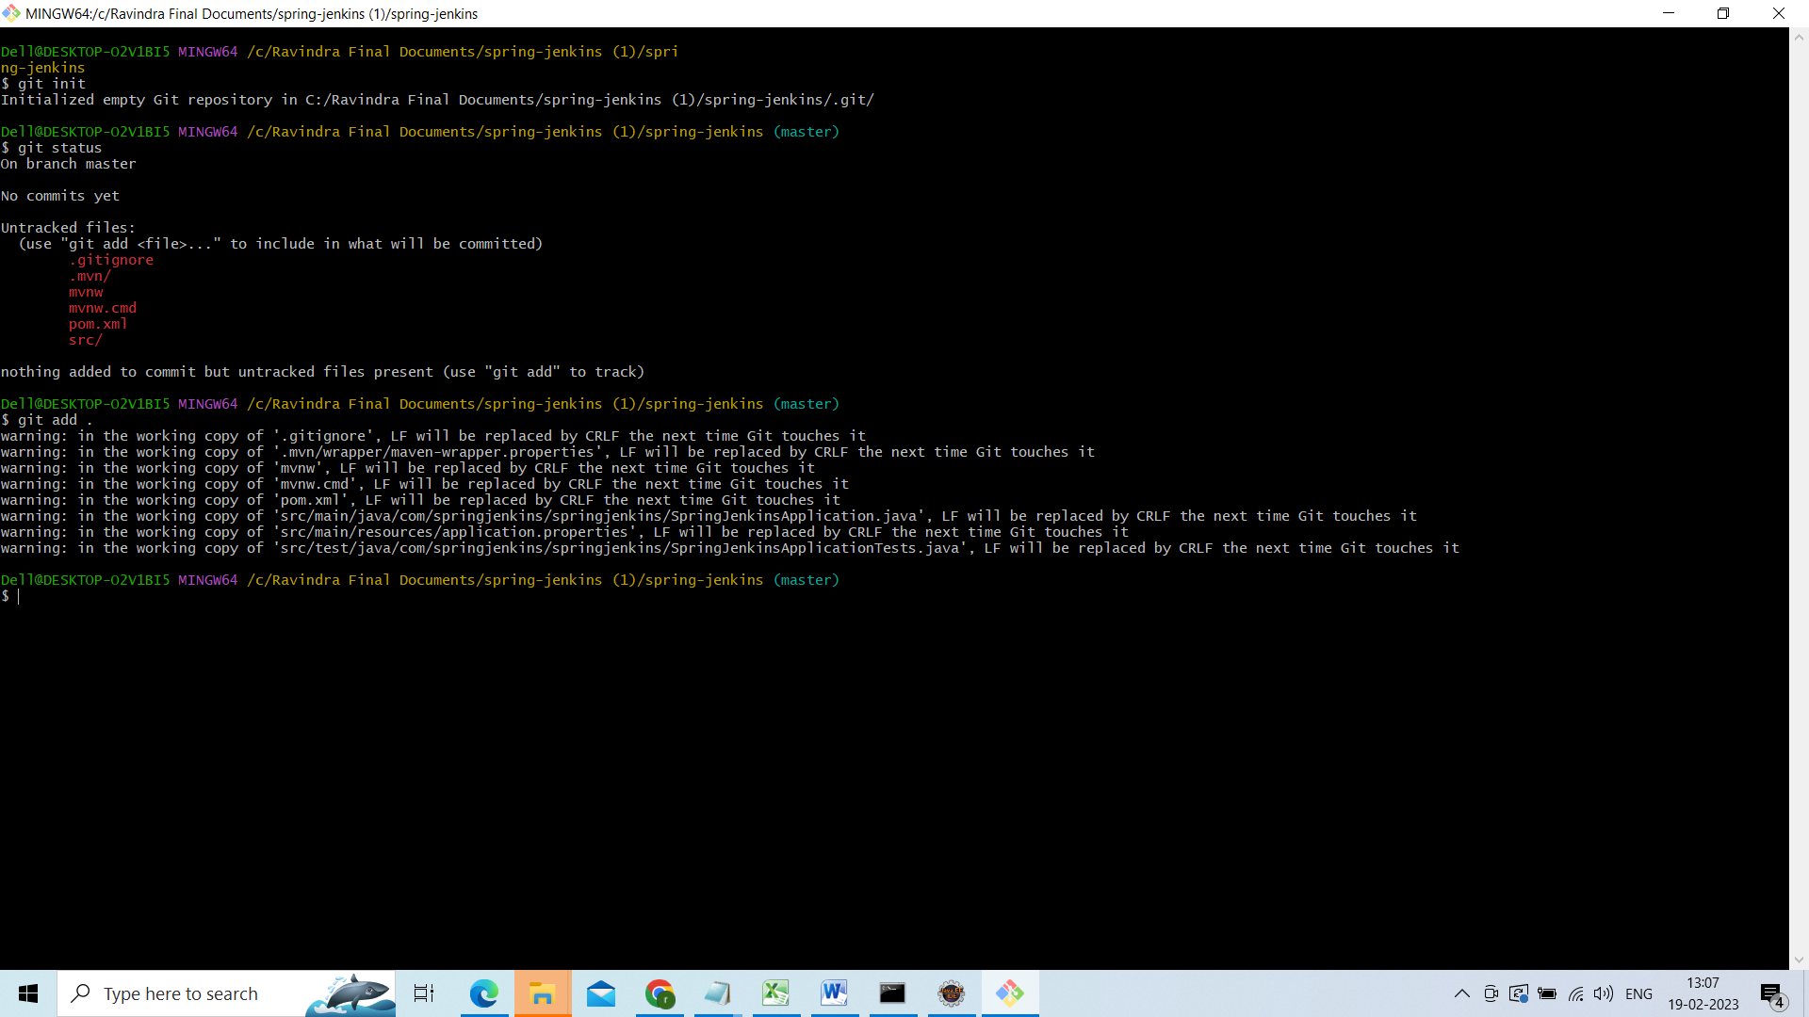

Then commit them

Git commit –m “commiting the message”

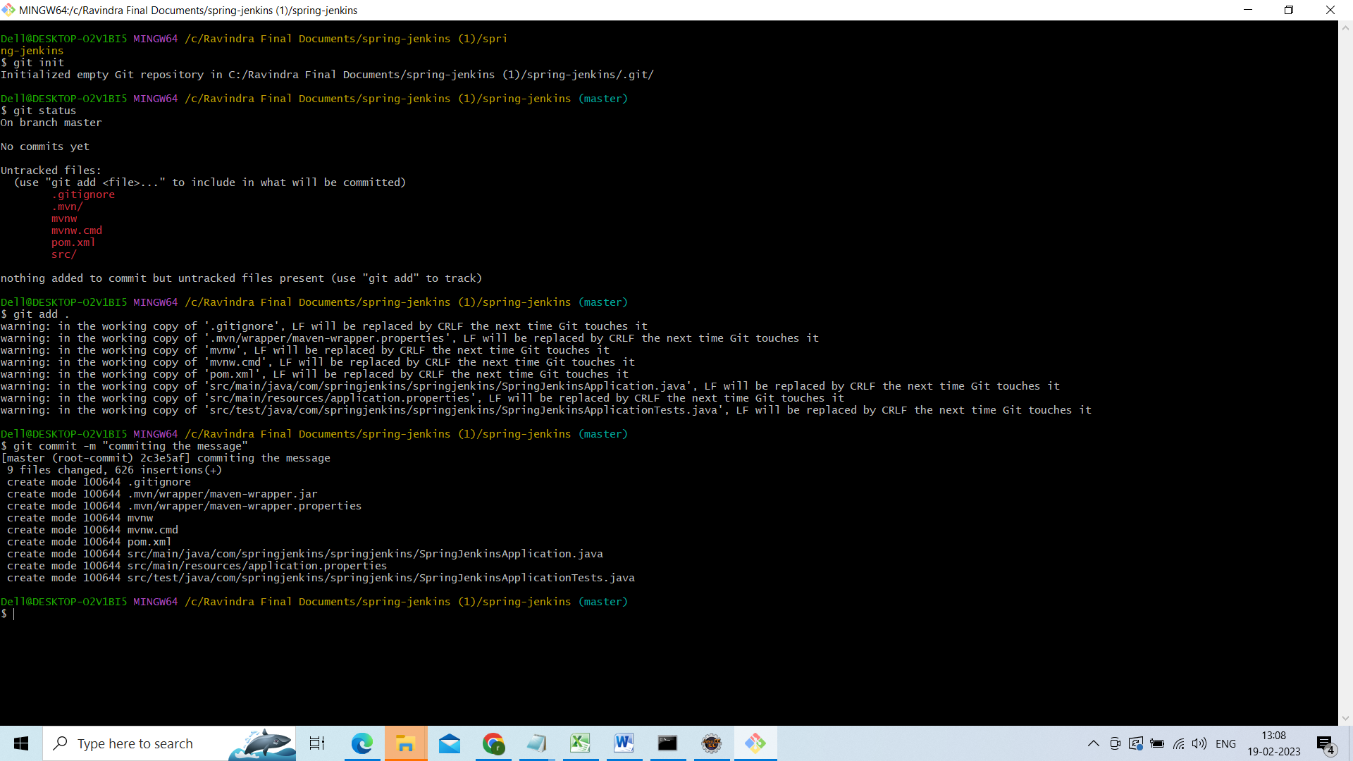

Add upstream and push to the remote repository

git remote add origin https://github.com/goud89105/spring-jenkins.git

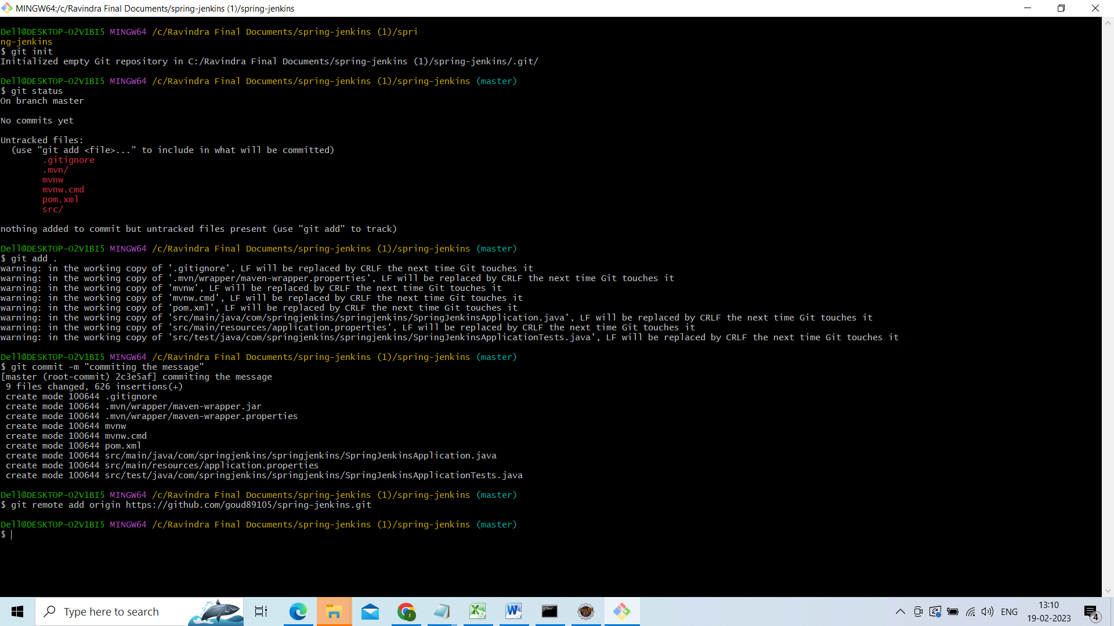

Then push our changes to the repository

git push -u origin main

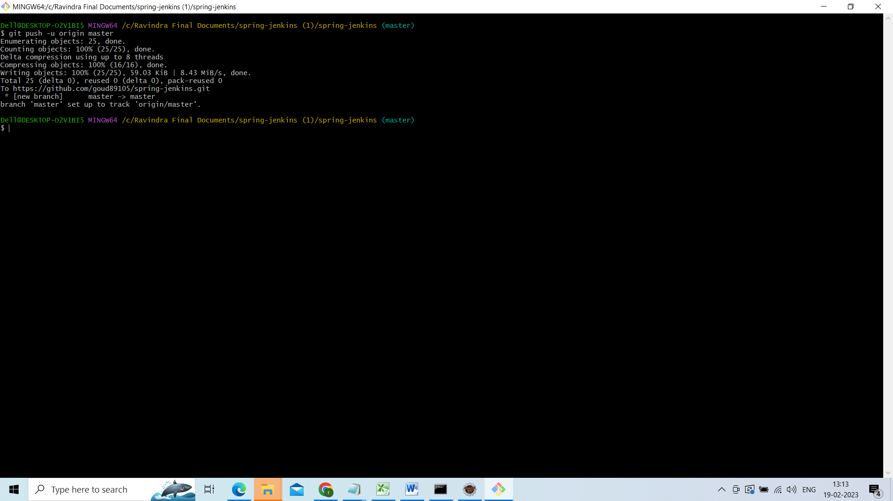

Now go to our repository means github

and lets refresh it.

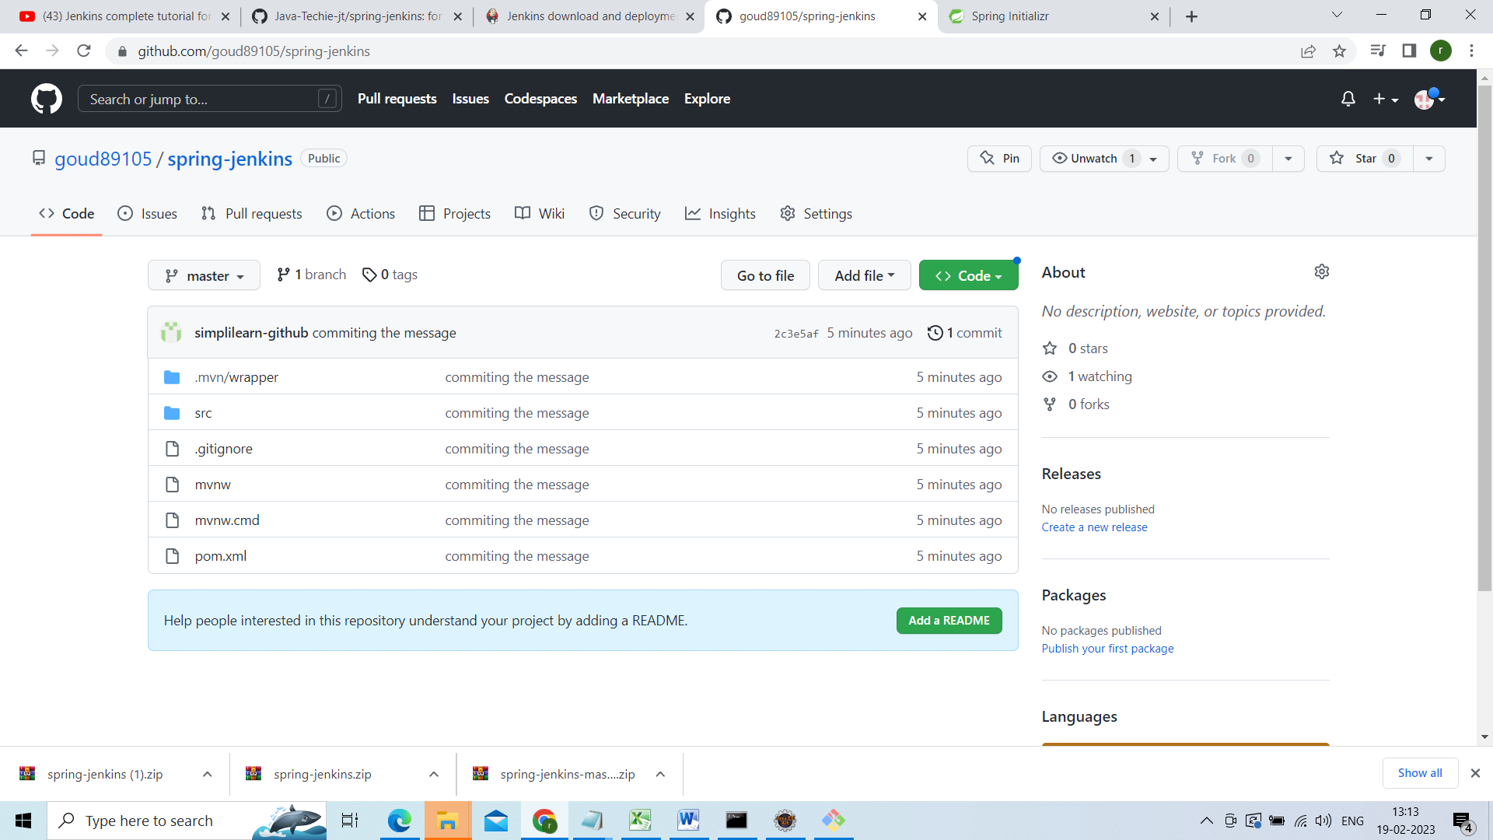

Now our application is sync with this repository.

Before going to create the job first install the maven in your local please refer this video for the same

<https://www.youtube.com/watch?v=km3tLti4TCM>

now setup the maven in your Jenkins

open Jenkins click on manage Jenkins

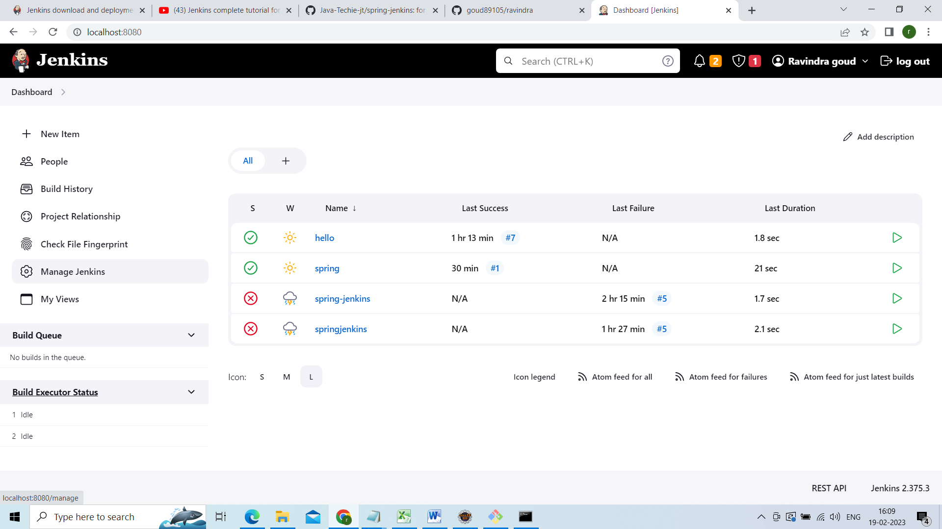

Click on manage plugins

Click on available plugins

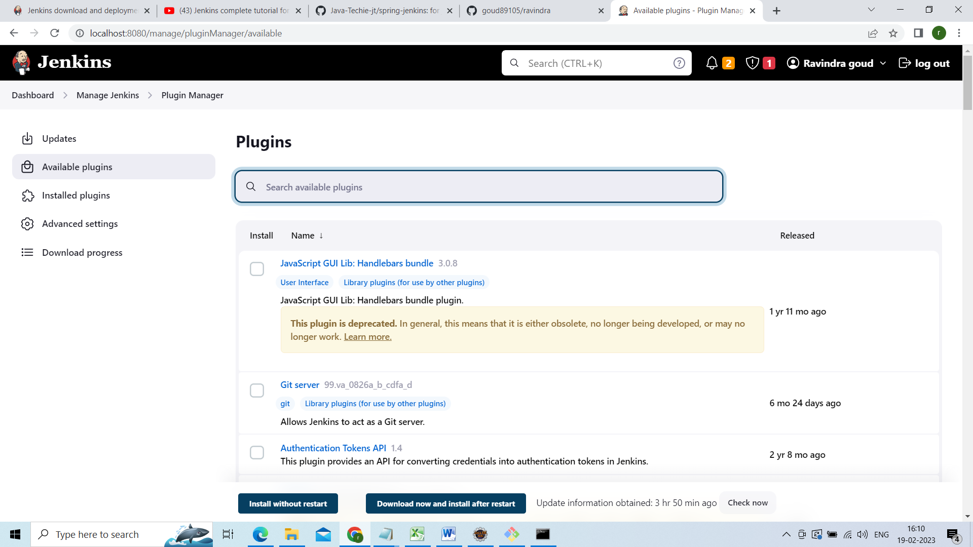

In plug in sercah box

Type maven integration

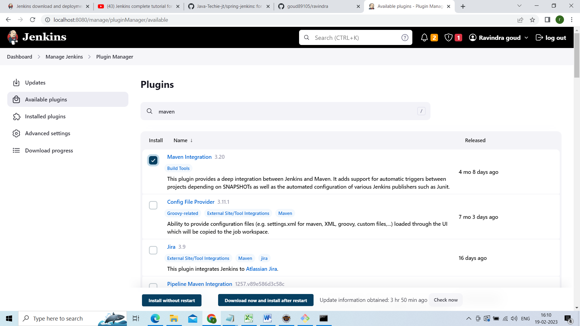

Click on download and install after that check the restarcheck box

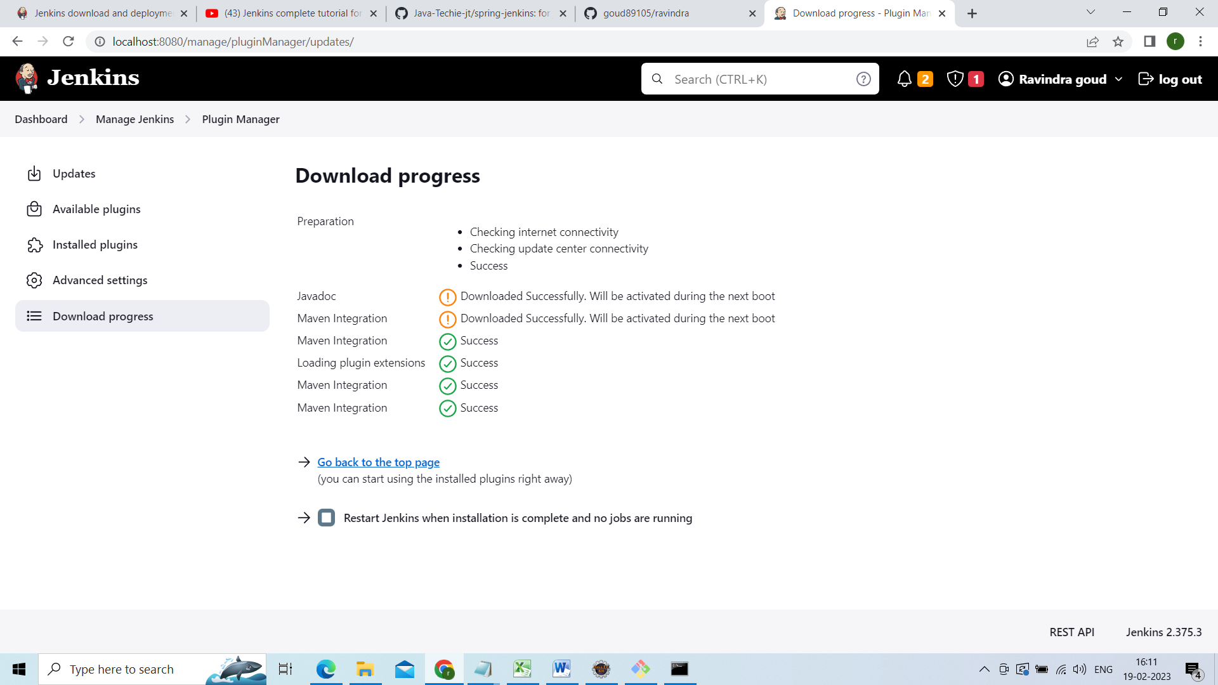

Now go to Jenkins dash board and create a new job

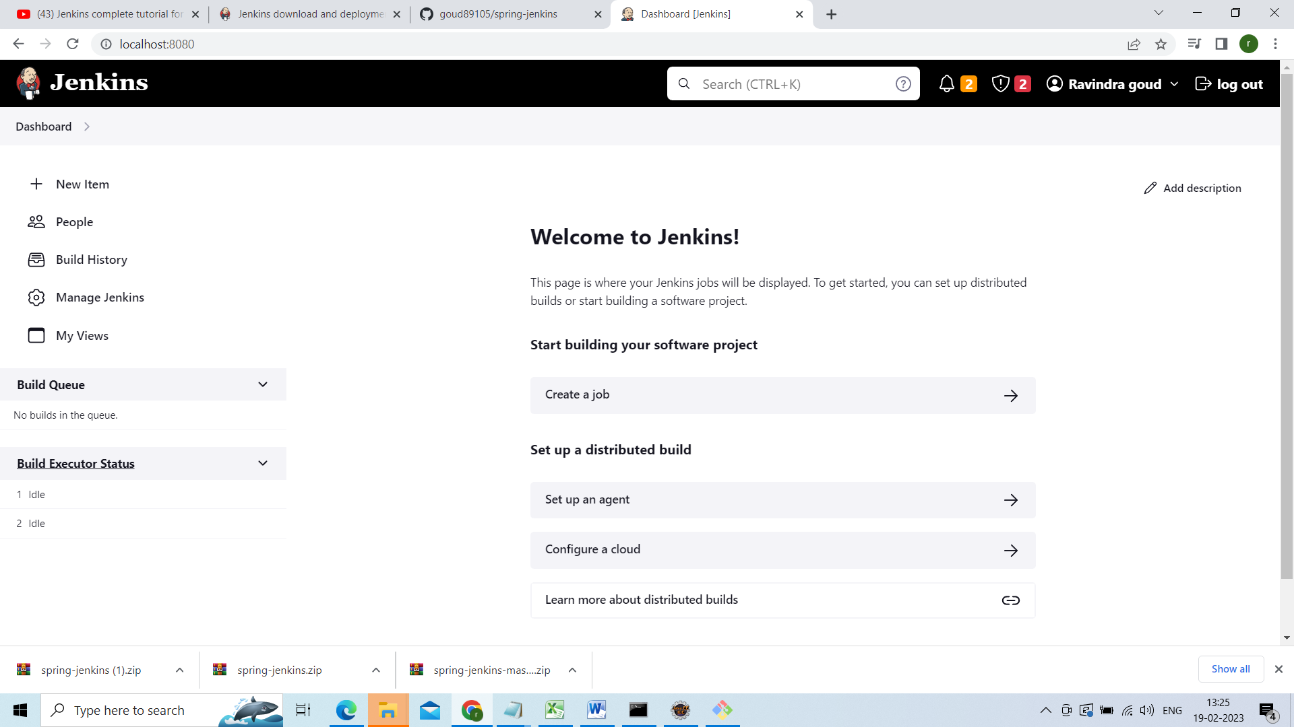

Click on create a job

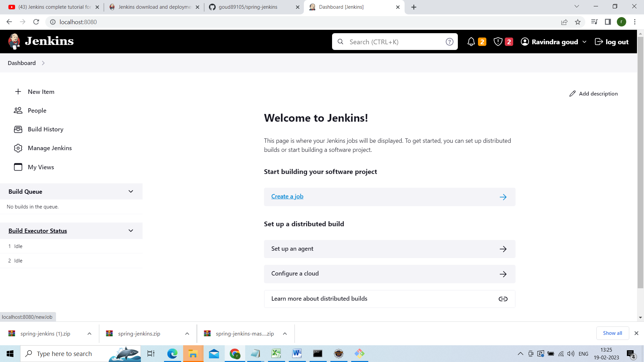

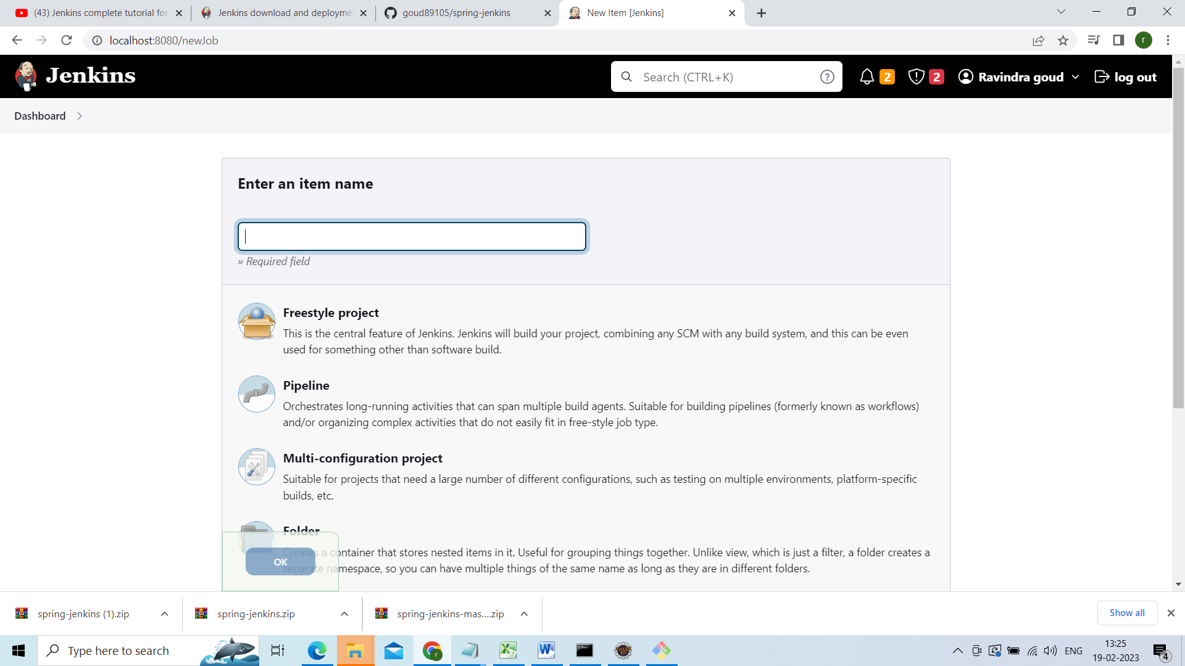

Mention the job name am giving the spring-jenkins

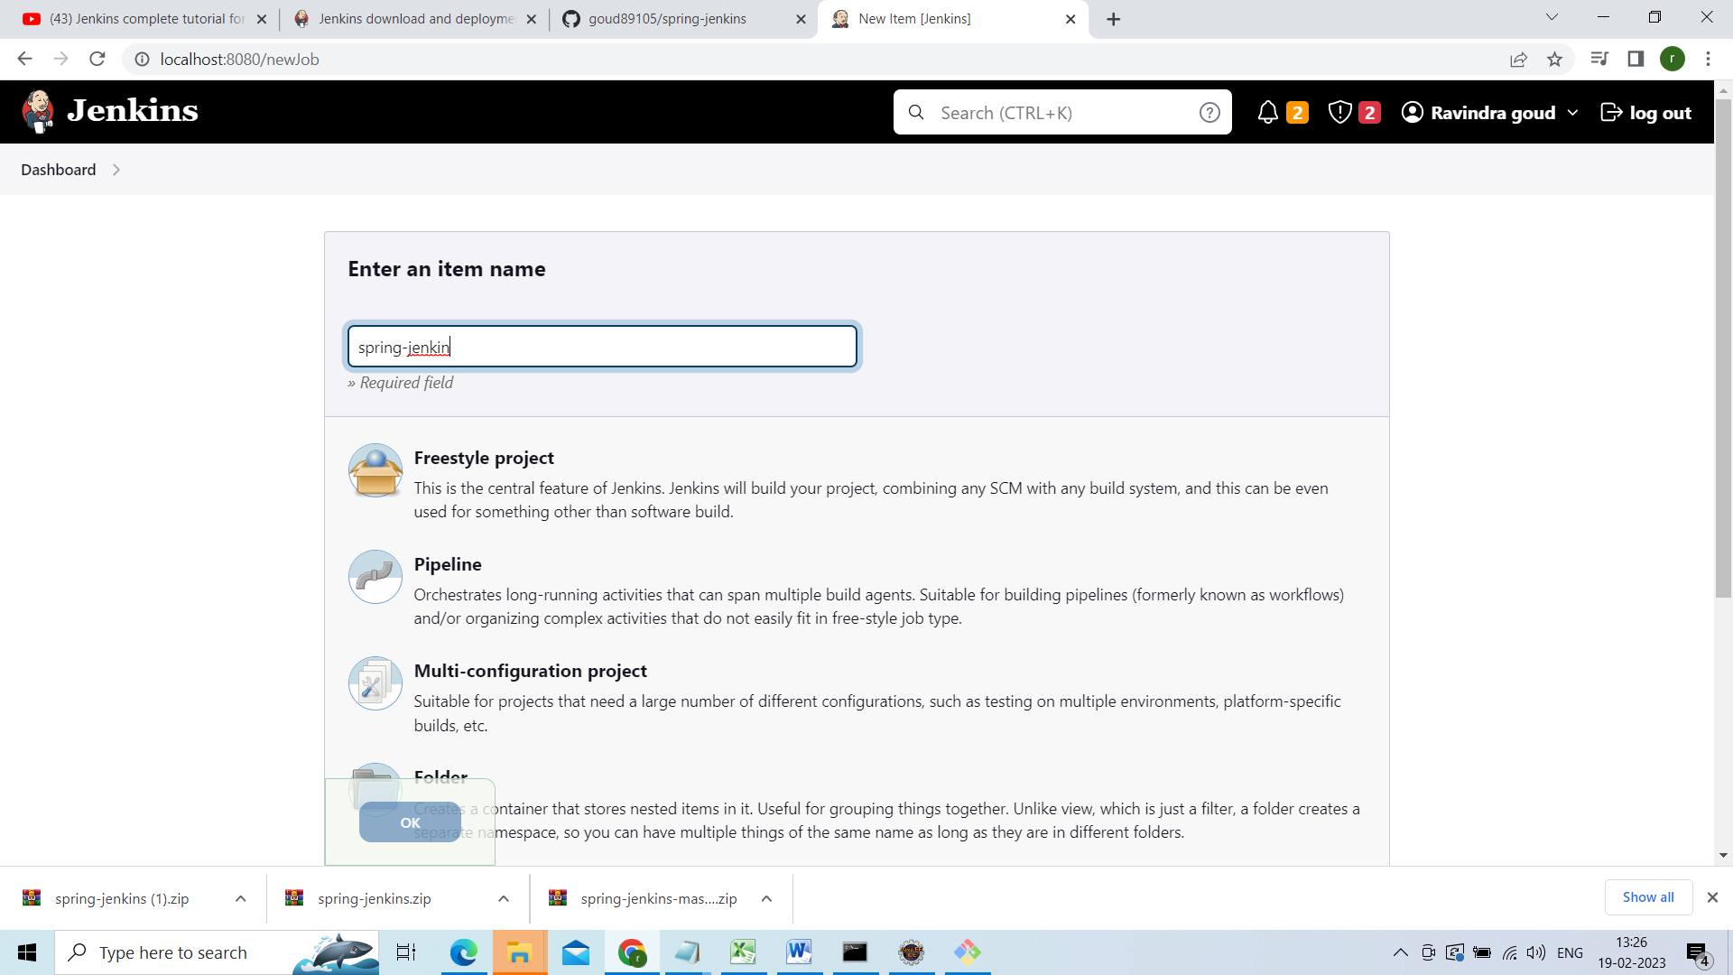

Click on freestyle project and click on ok

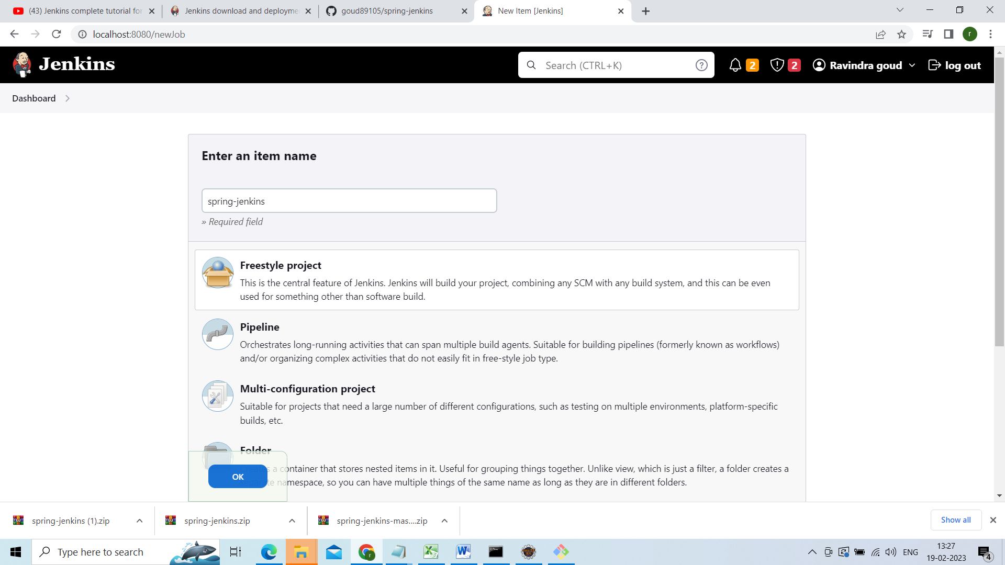

As we are going to build the github project select github and give the project URL

<https://github.com/goud89105/spring-jenkins> this is my project URL

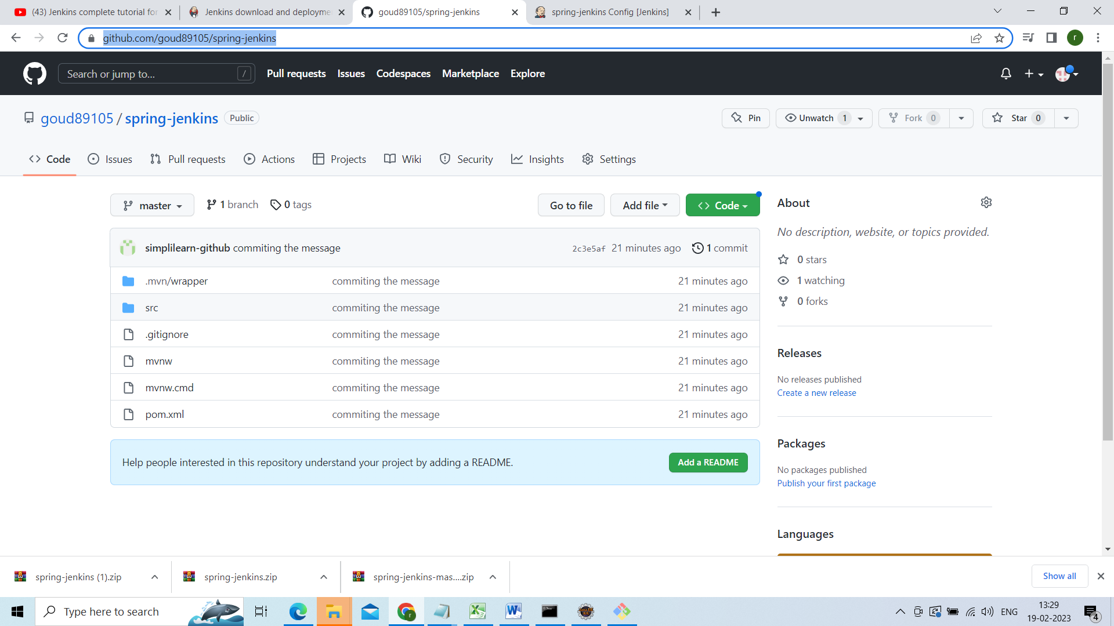

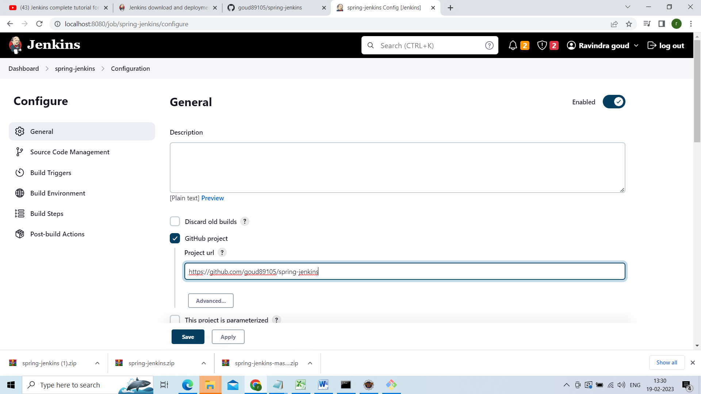

Click on advance and give spring Jenkins

Under source code management select git

Give repository url u will get repository url from git hub under code copied that url

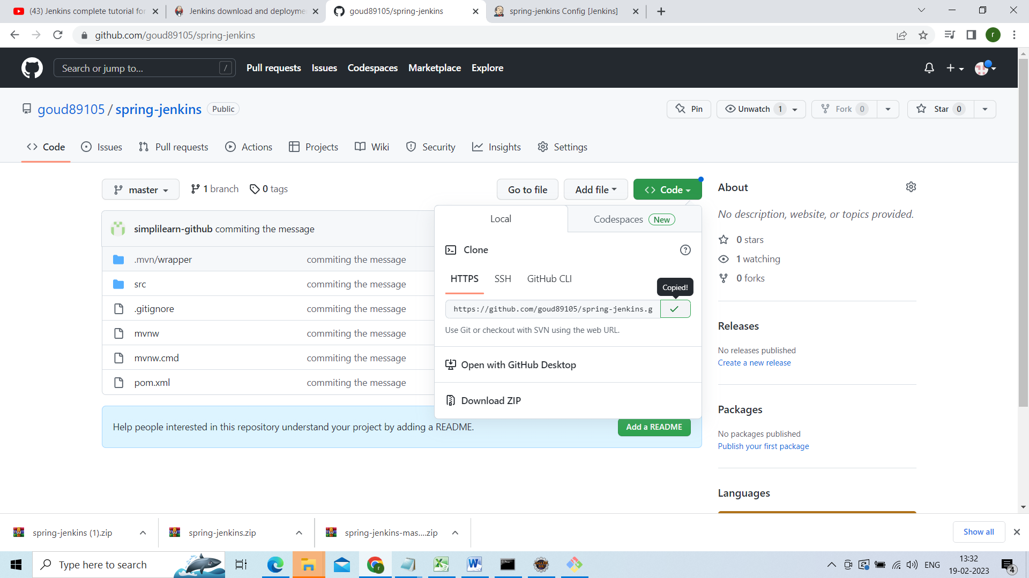

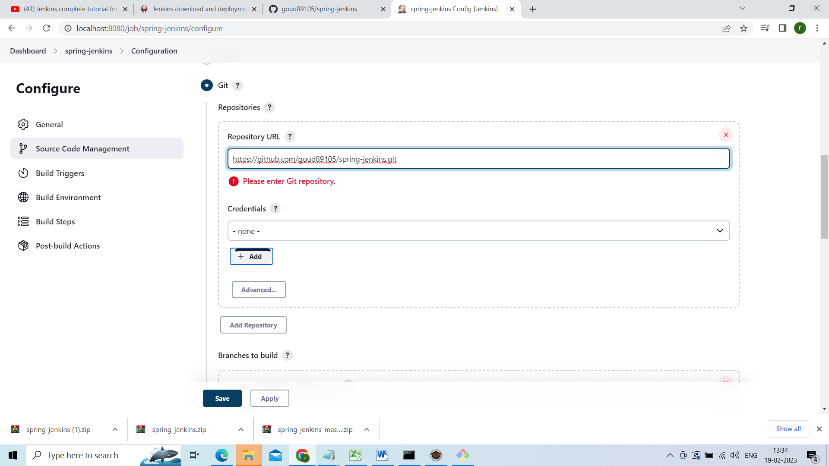

Add ur credentials under click on add

After that from credentials drop down u can select ur credentials

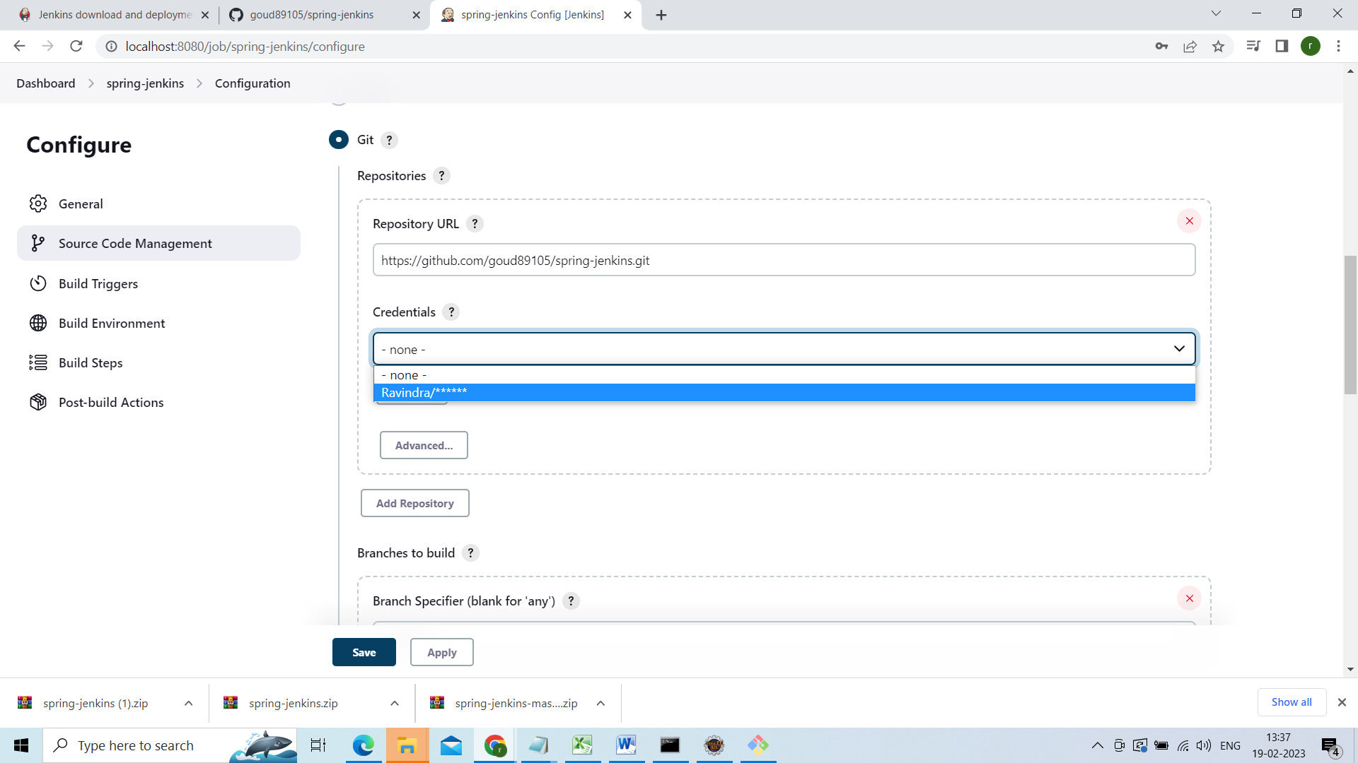

Under build triggers give * * * * * means every hour every minute automatically build will be triggered

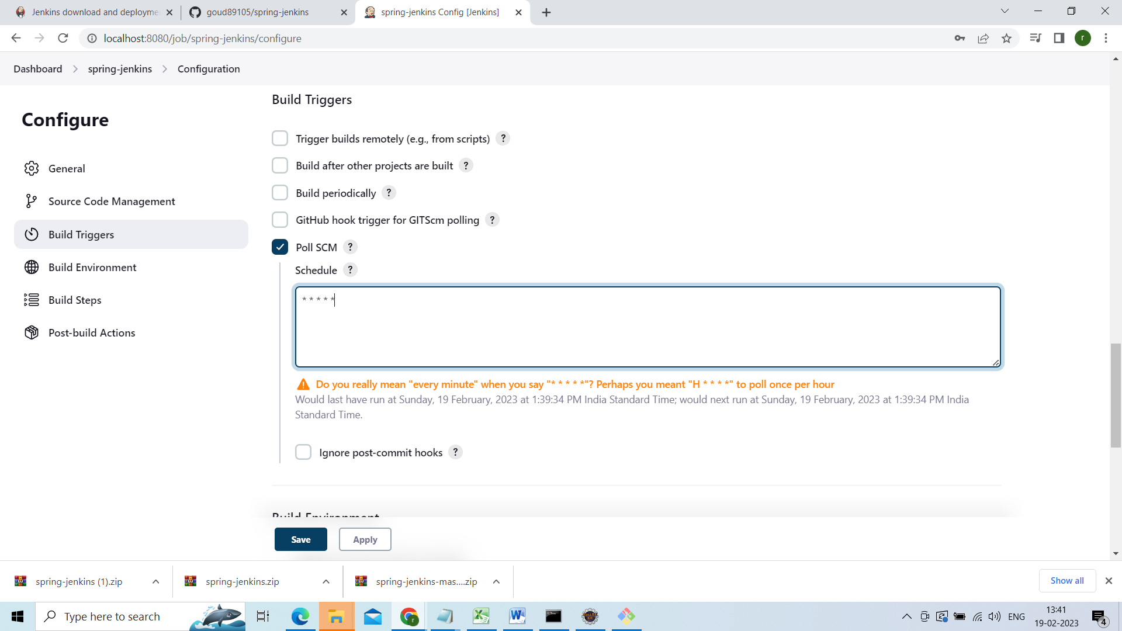

Under build steps select i**nvoke top-level Maven targets**

**Under goals give install**

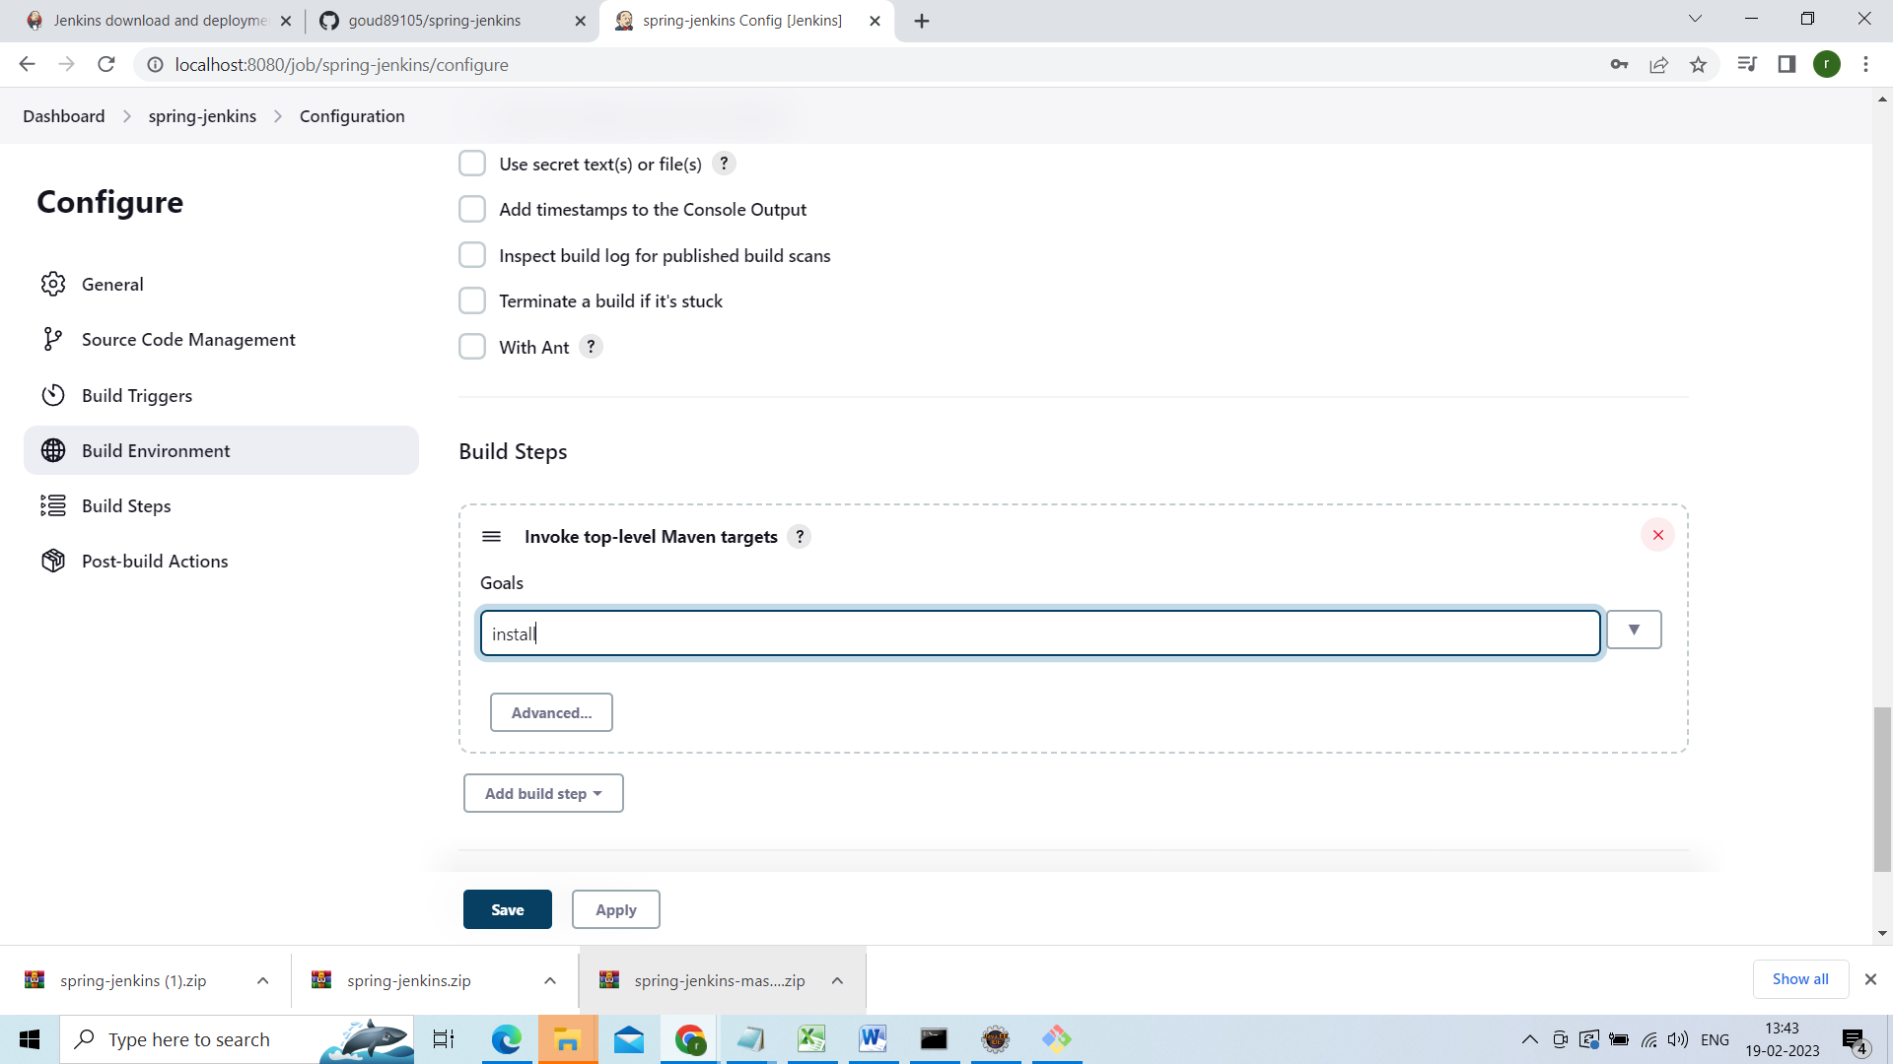

Now click on apply

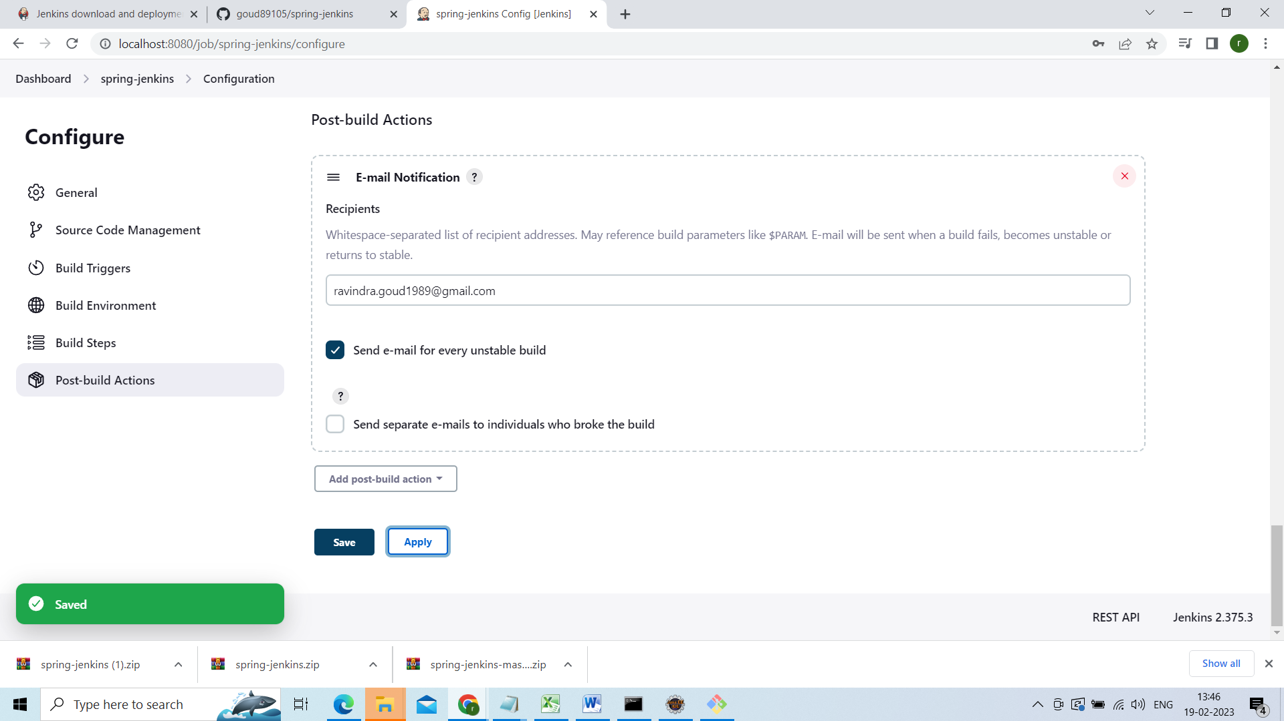

Now go to the spring-jenkins

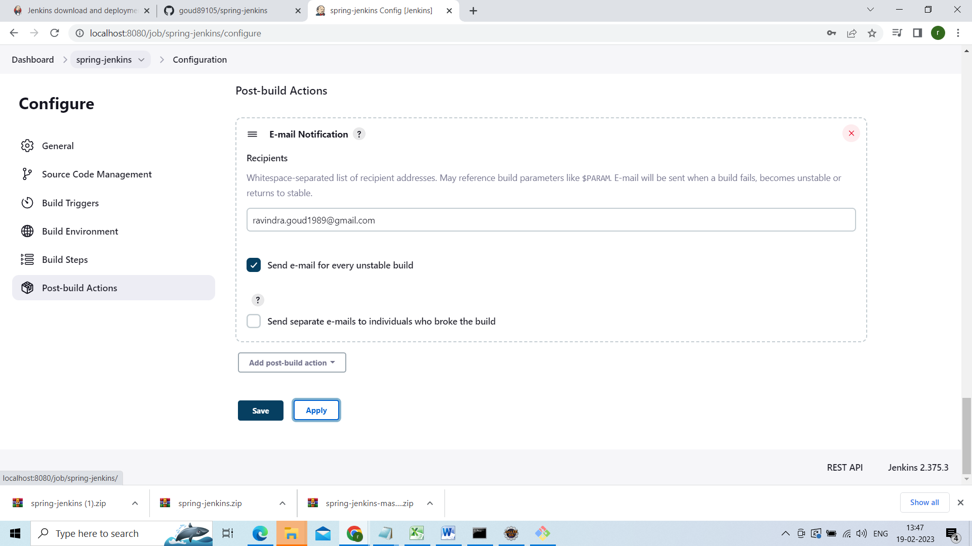

Click on build now

And see console output from dropdown

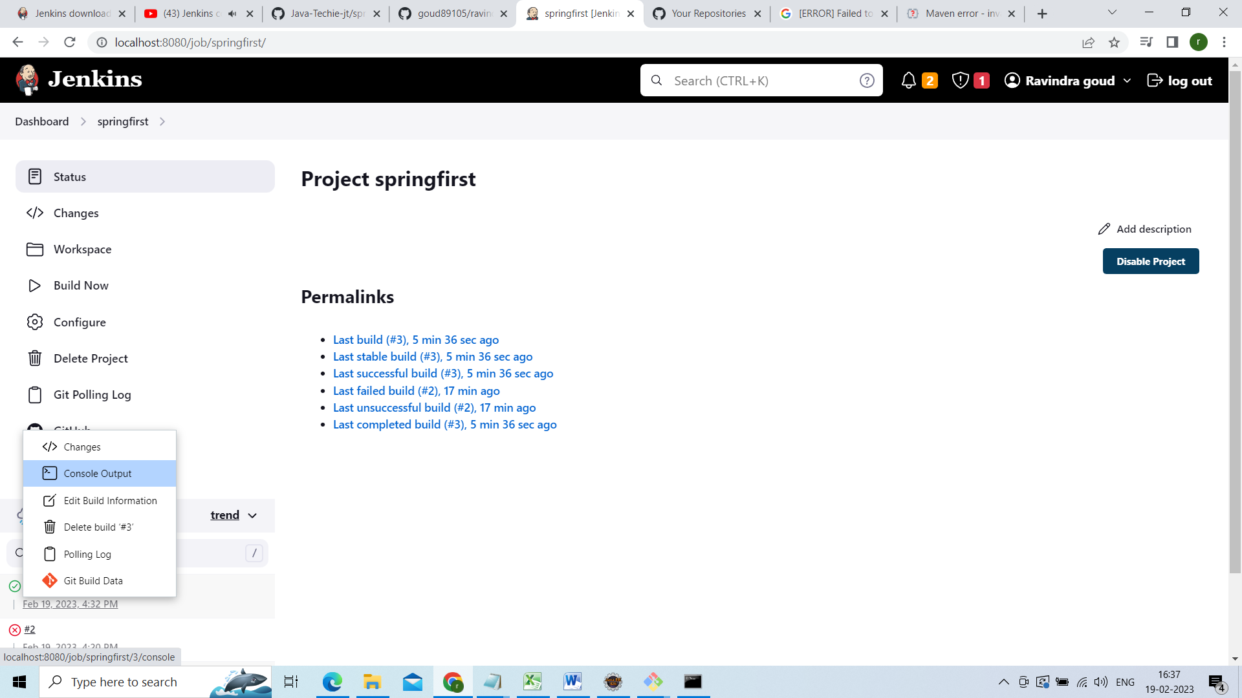

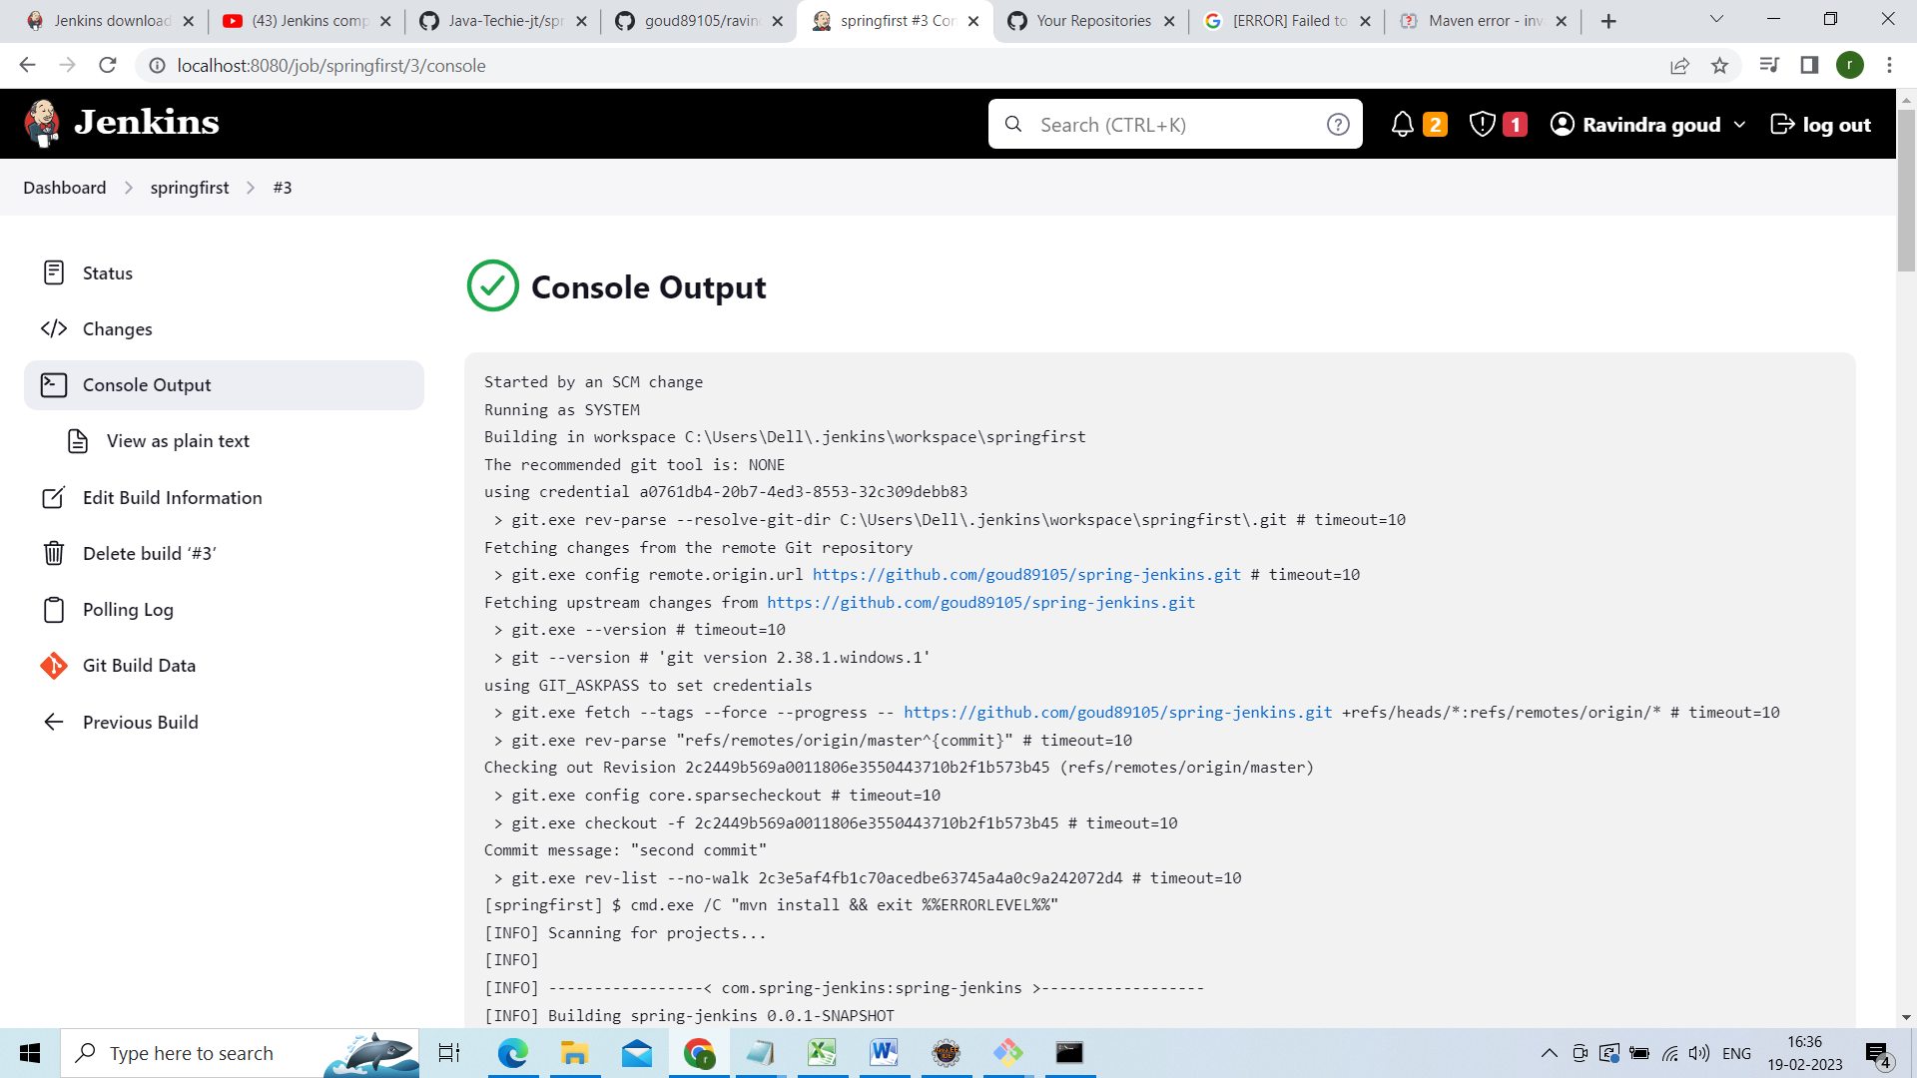

Now let me show u how this build automated for that go your project do some changes and push ur chages to remote repository

Done some chages in the below file

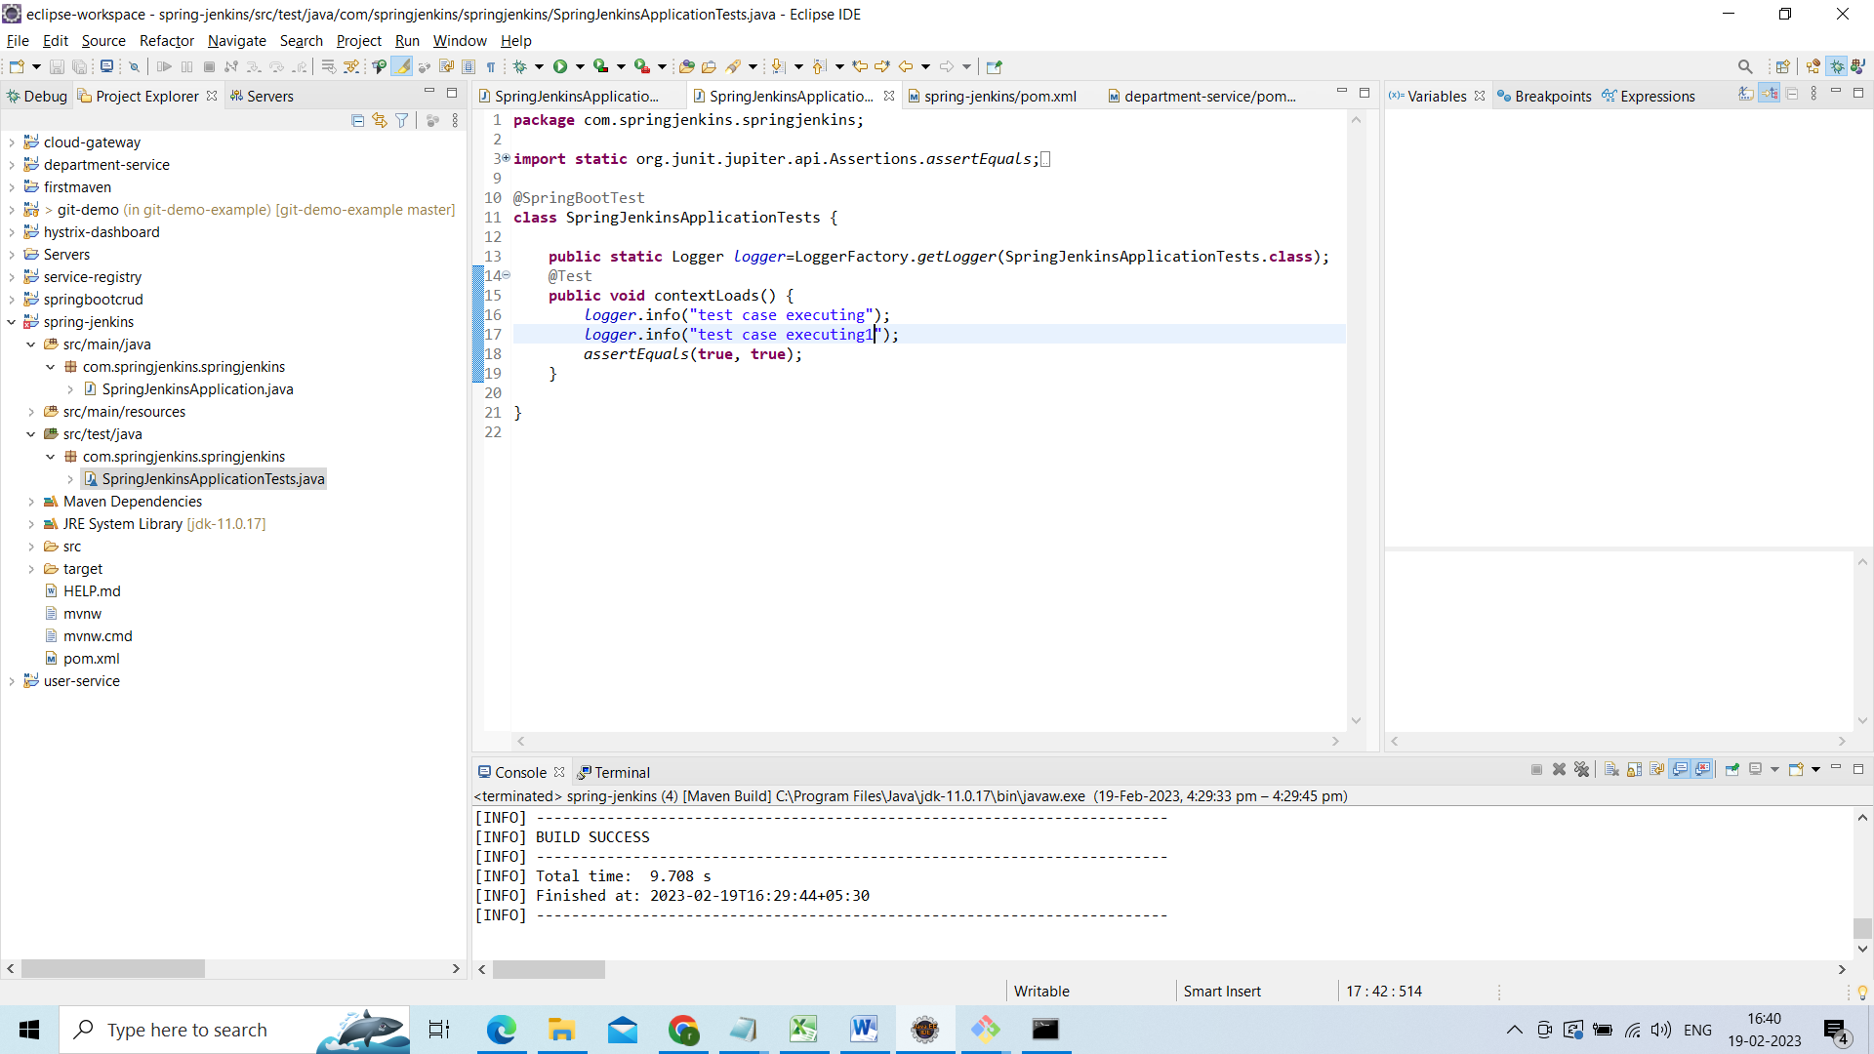

Now go to git bash and see status

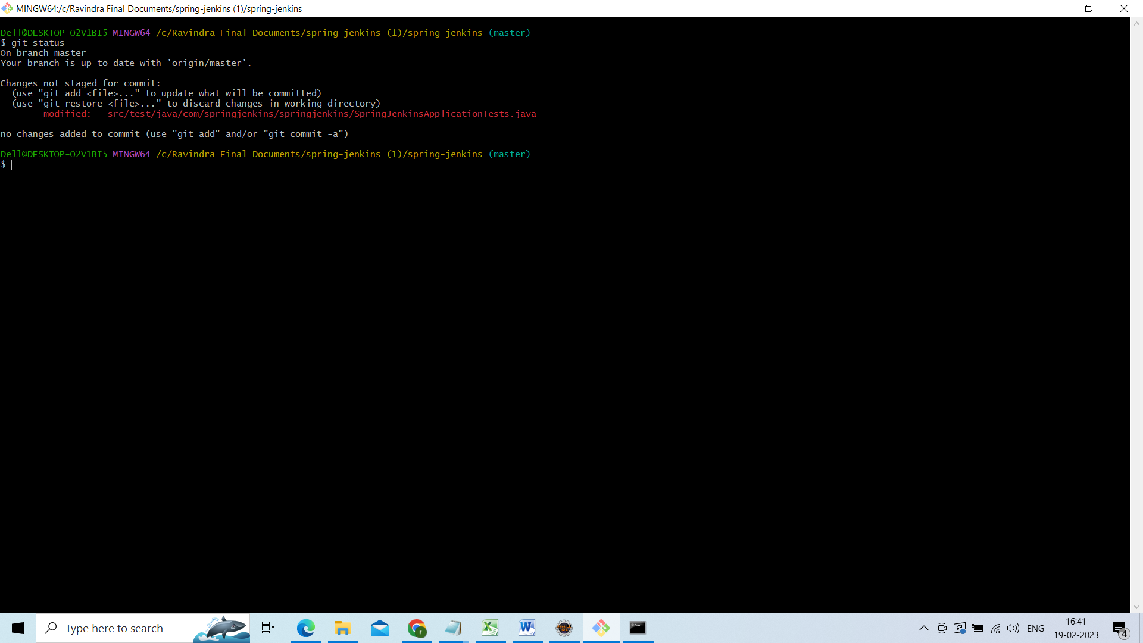

Add to statging area and push to remote repository build automatically triggered

Git add .

Git commit –m “third commit”

Git push –u origin master

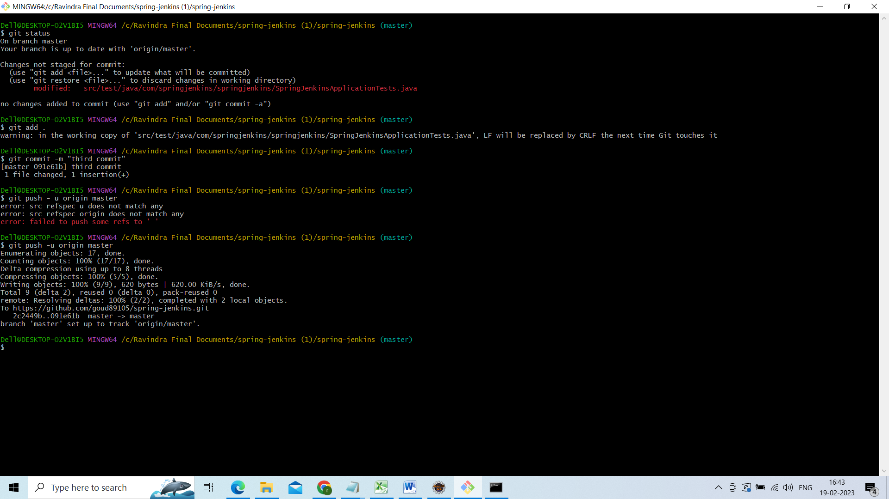

Now to git hub u r changes will be there and go to Jenkins automatically build will be triggered with ur changes

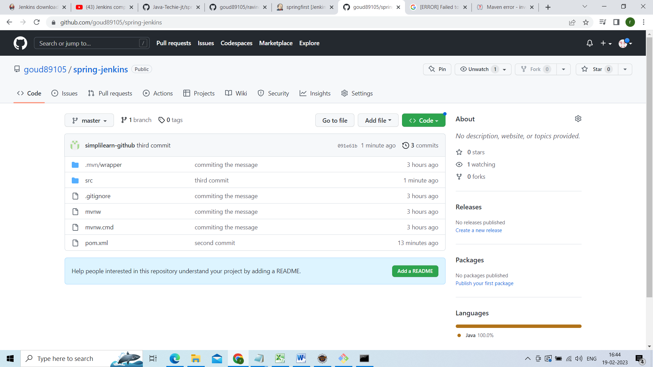

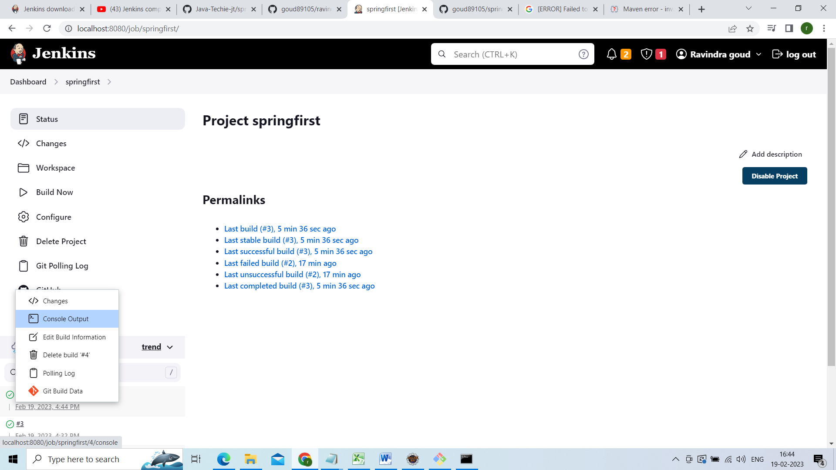

Now am going to add email releated configuration

Go to dashboard and click on manage Jenkins

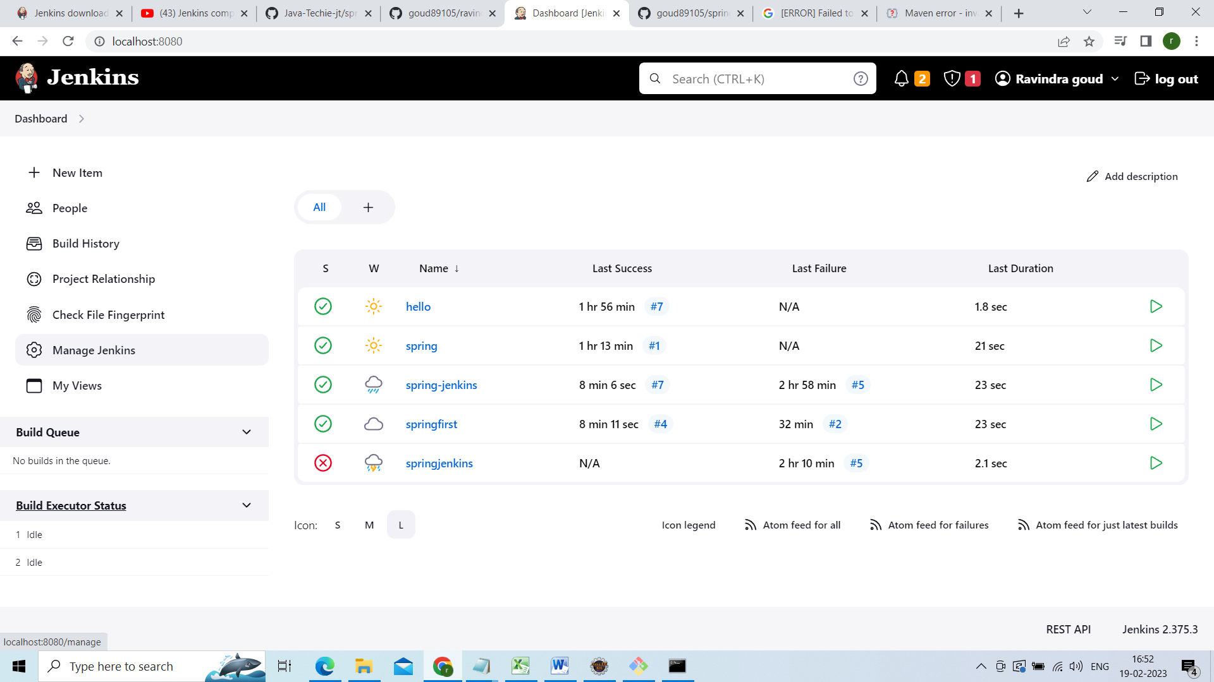

Click on configure system

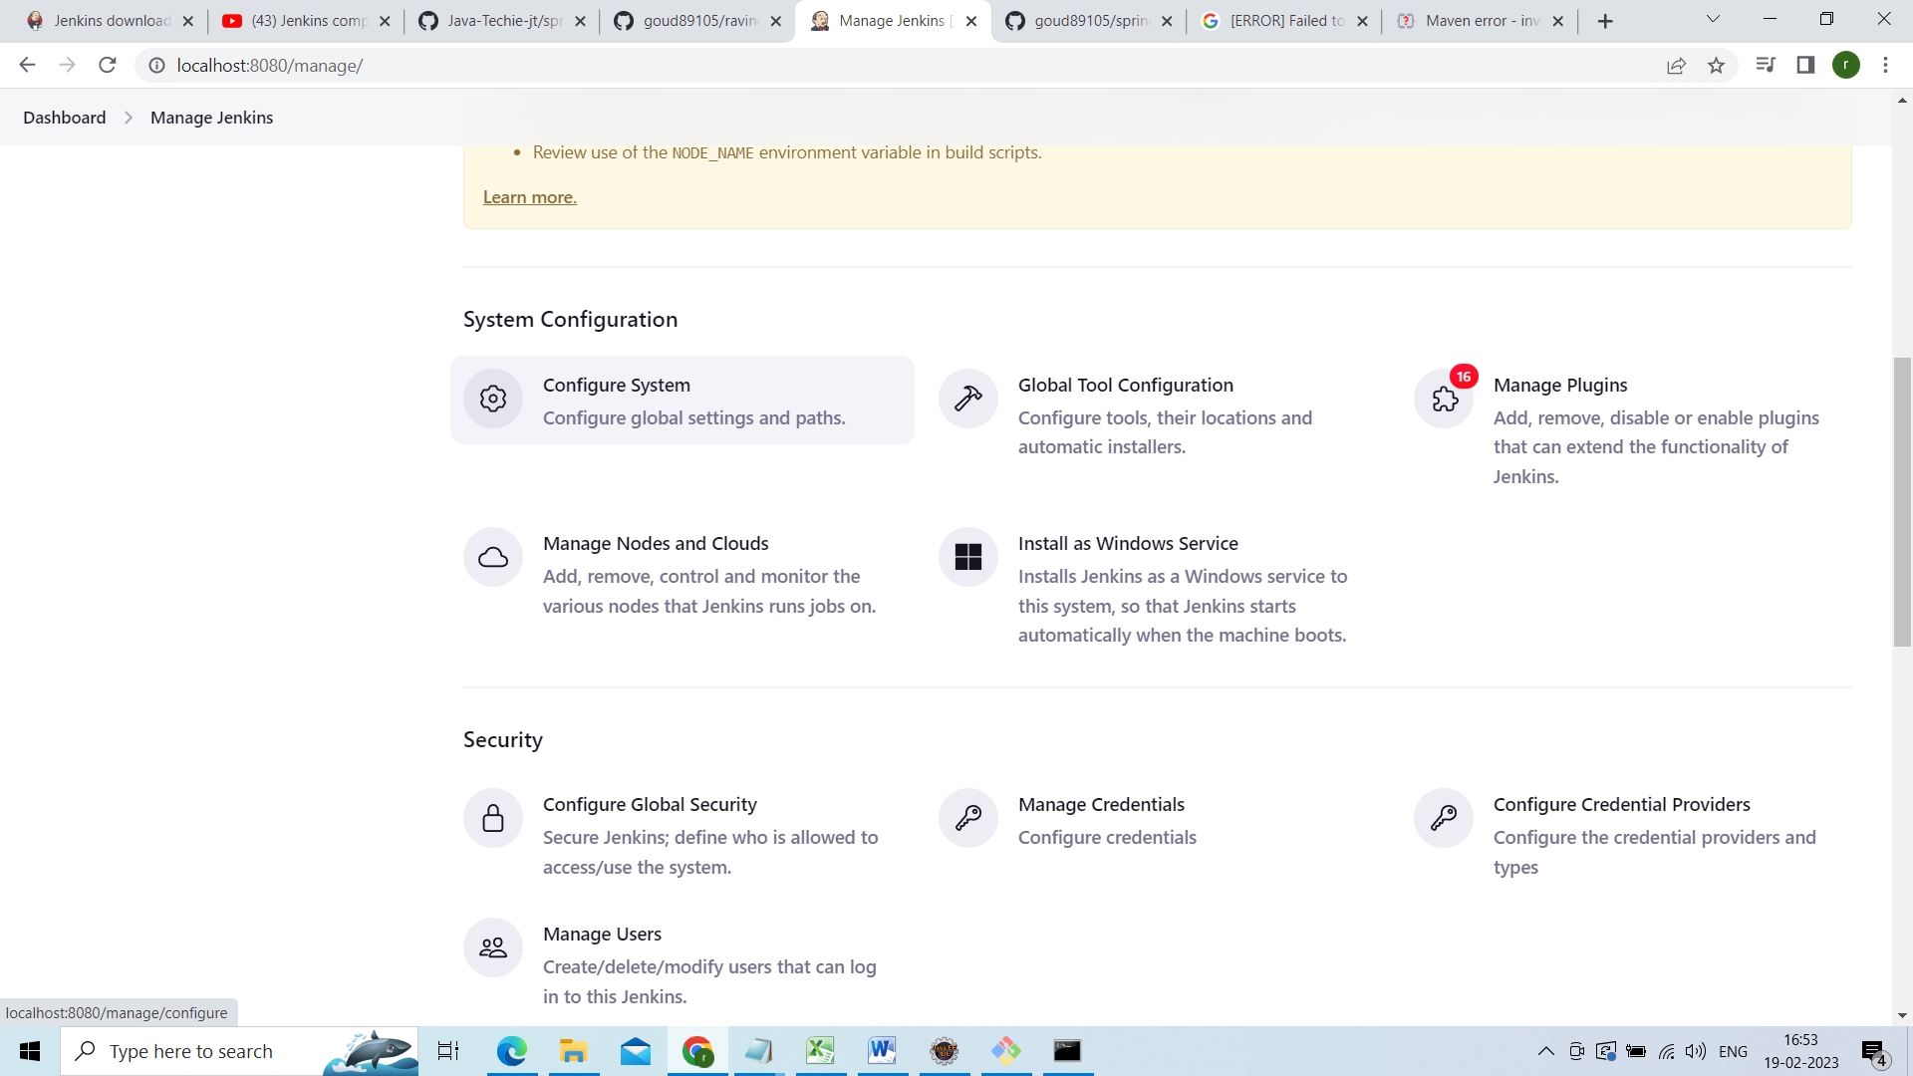

Come down

Under email notification give smtp.gmail.com

Under Default user e-mail suffix[?](http://localhost:8080/manage/configure)

Add @gmail.com

Click on advanced select smtp authentication

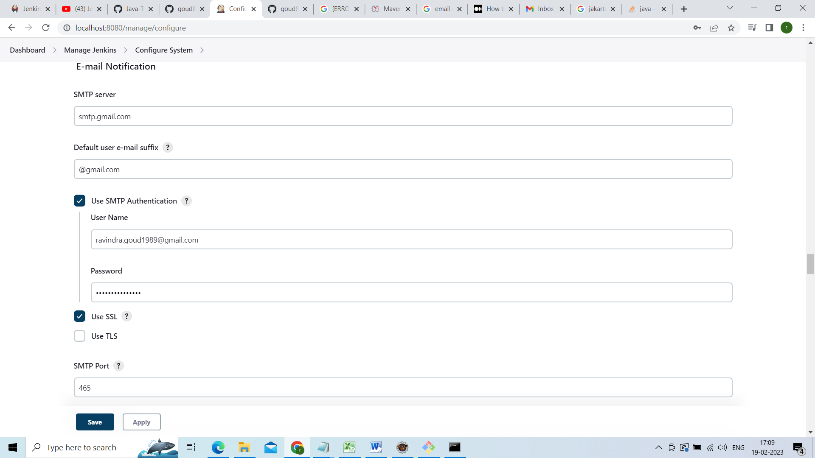

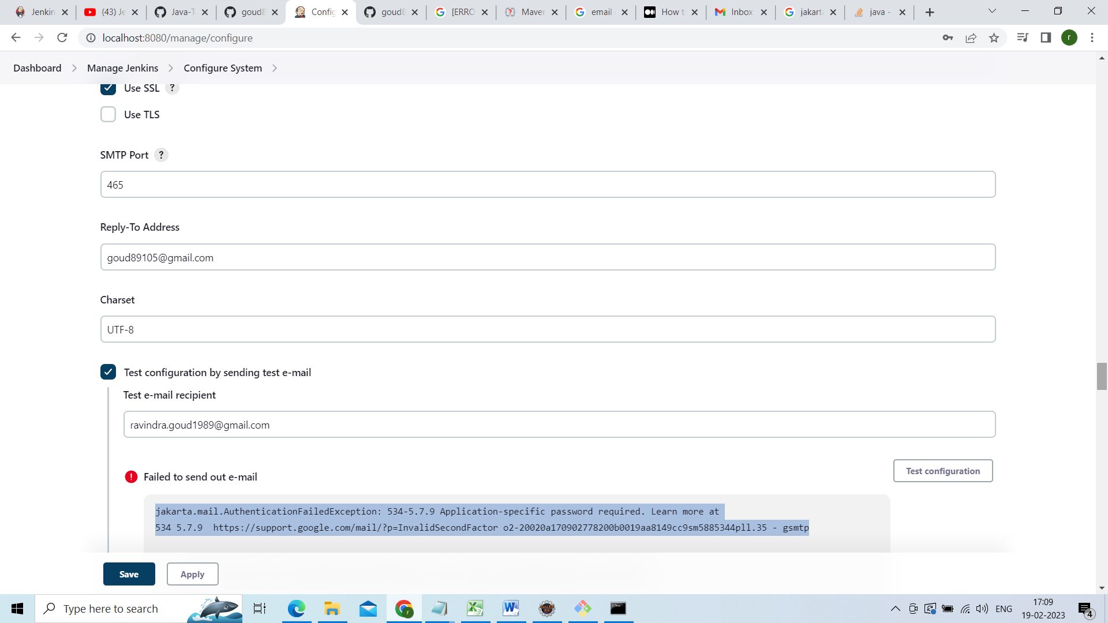

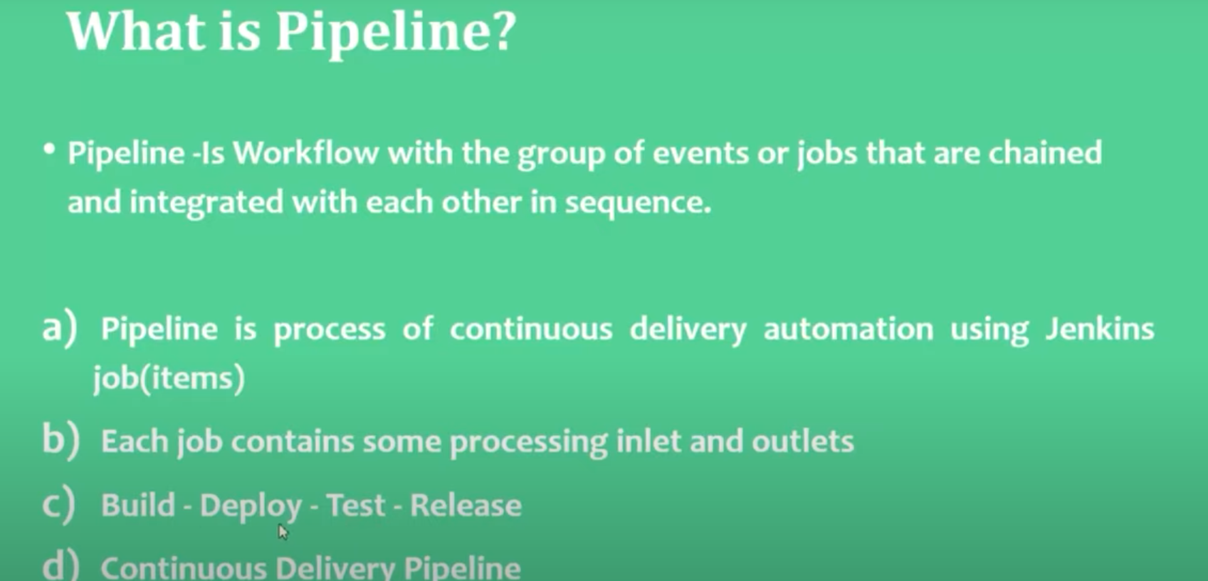

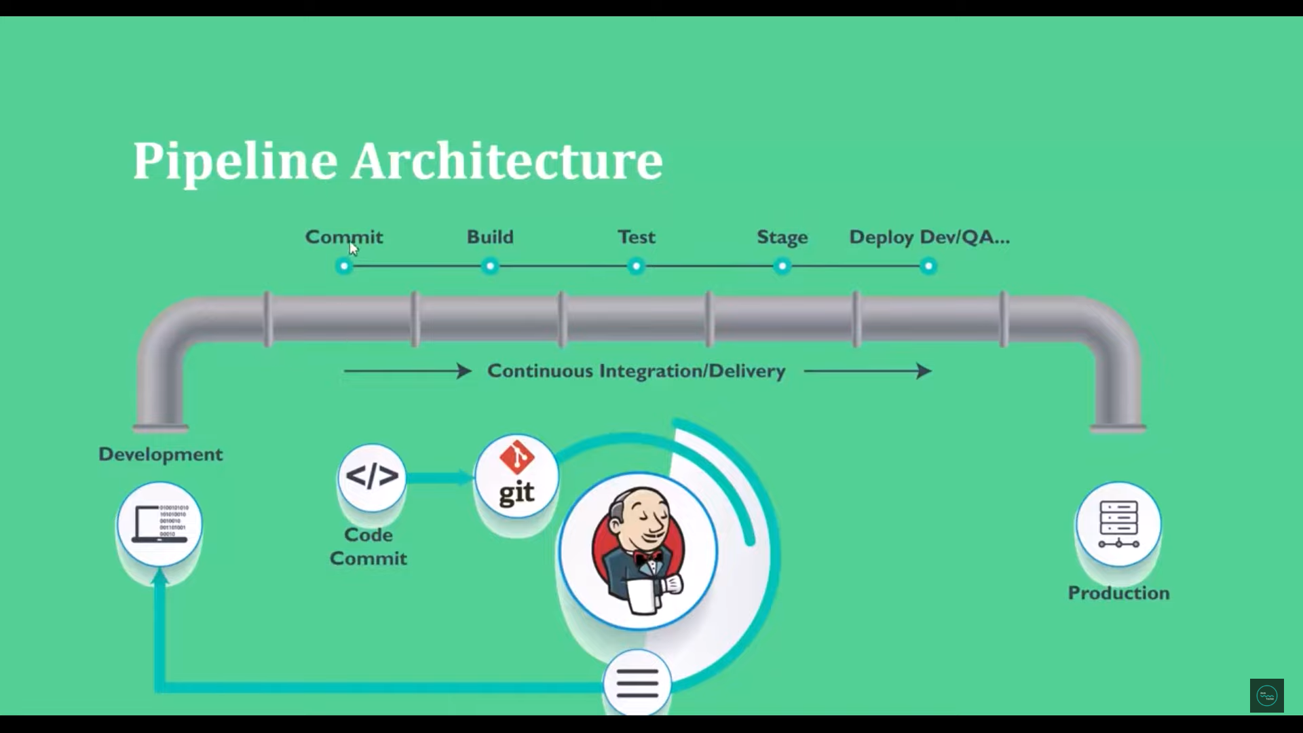

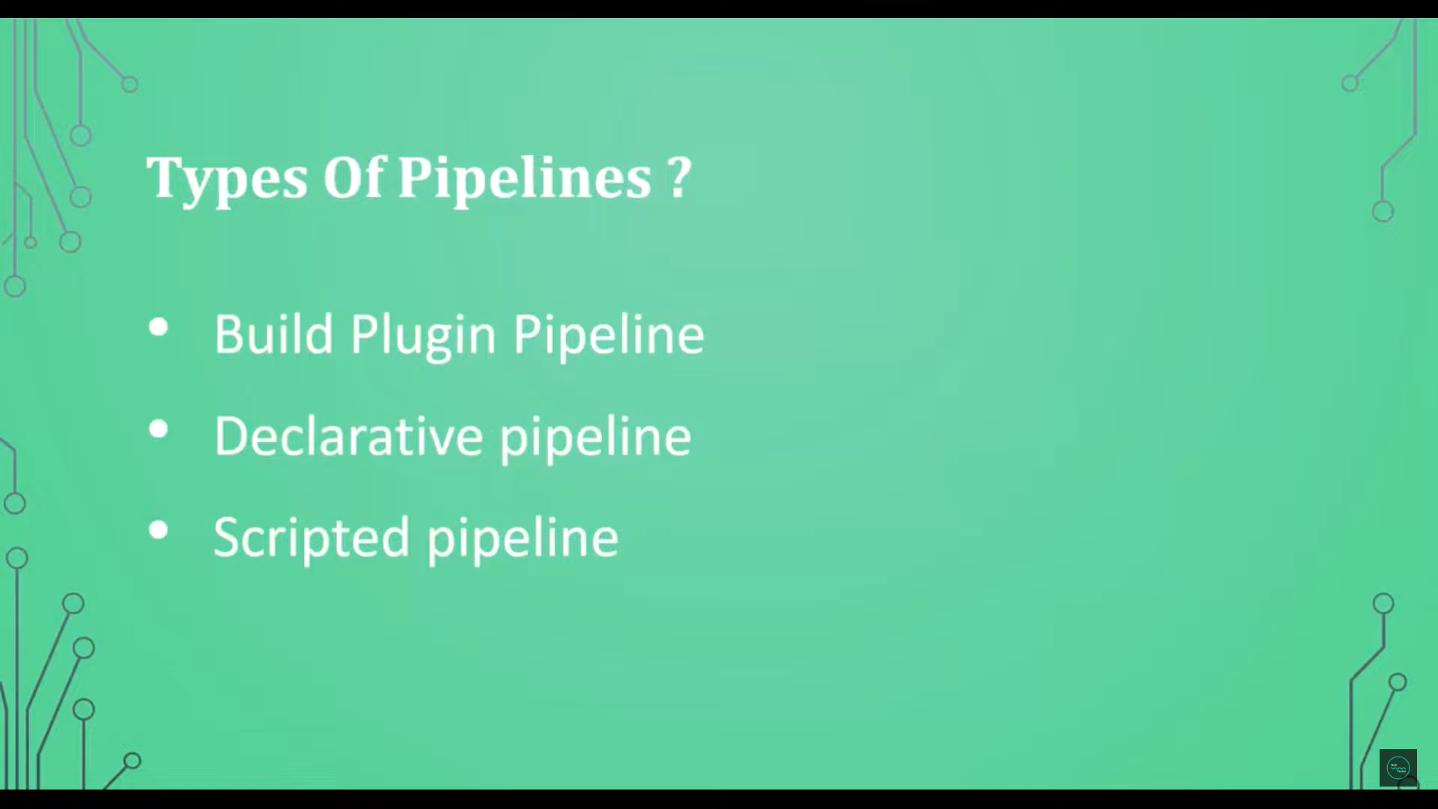

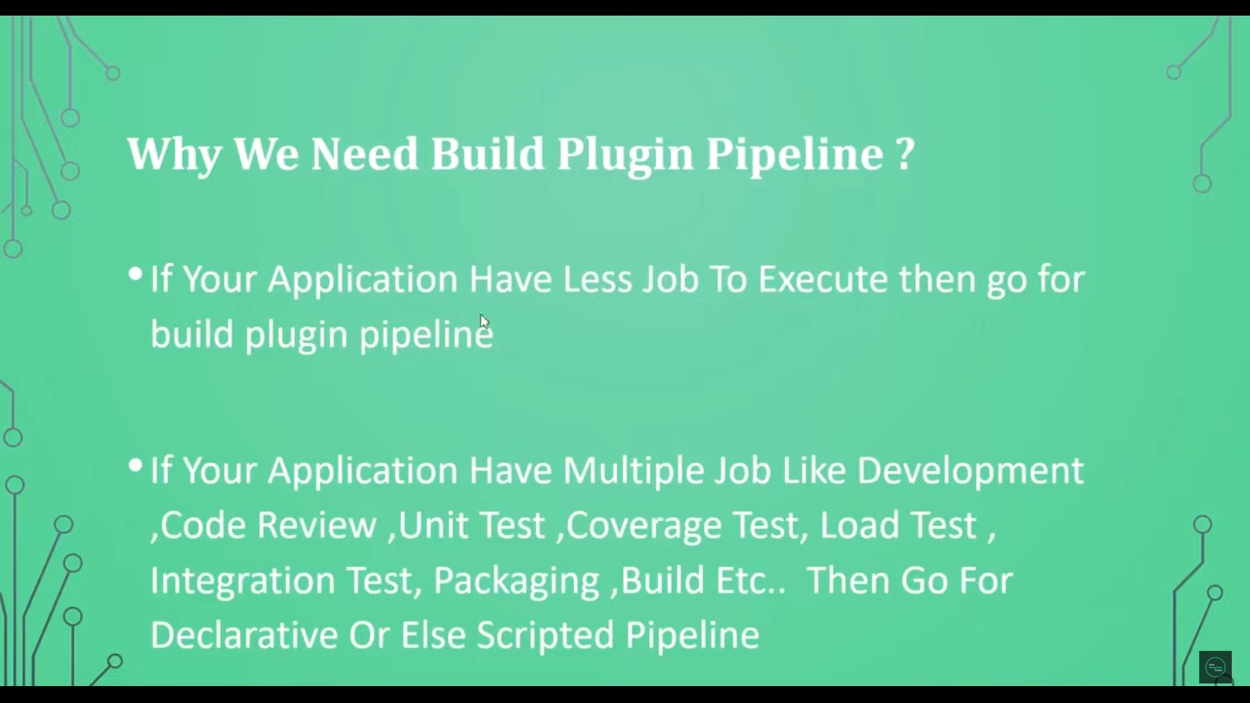

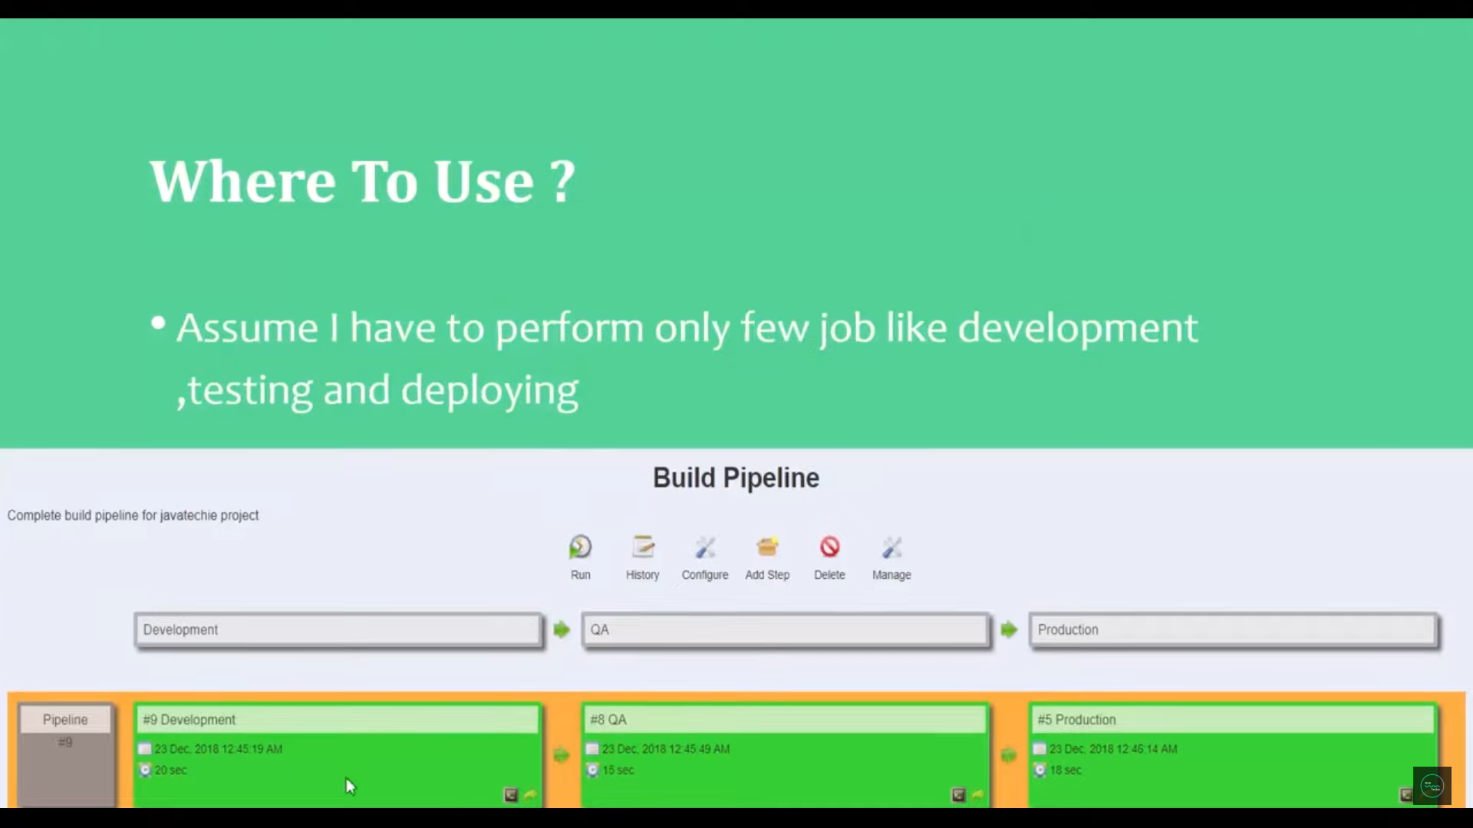

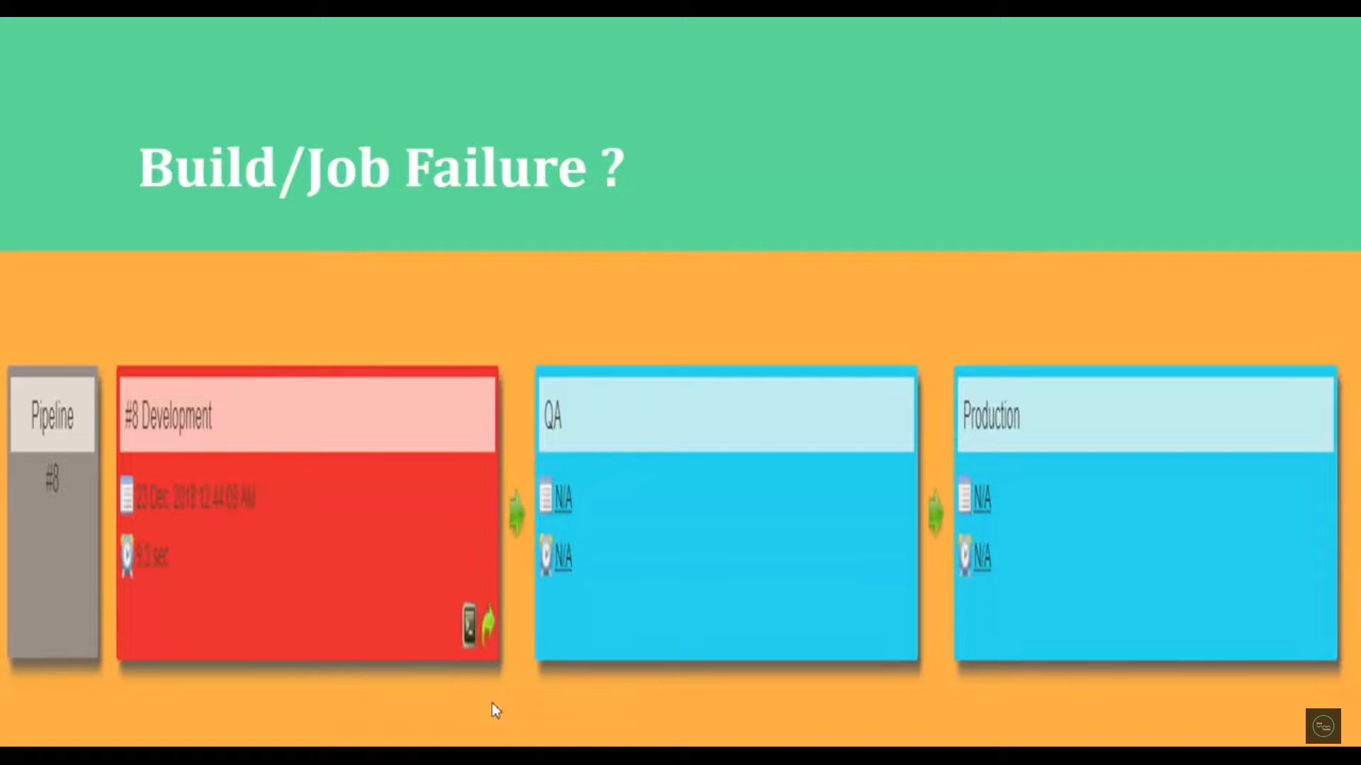

Go to Jenkins dashboard

Click on newitem

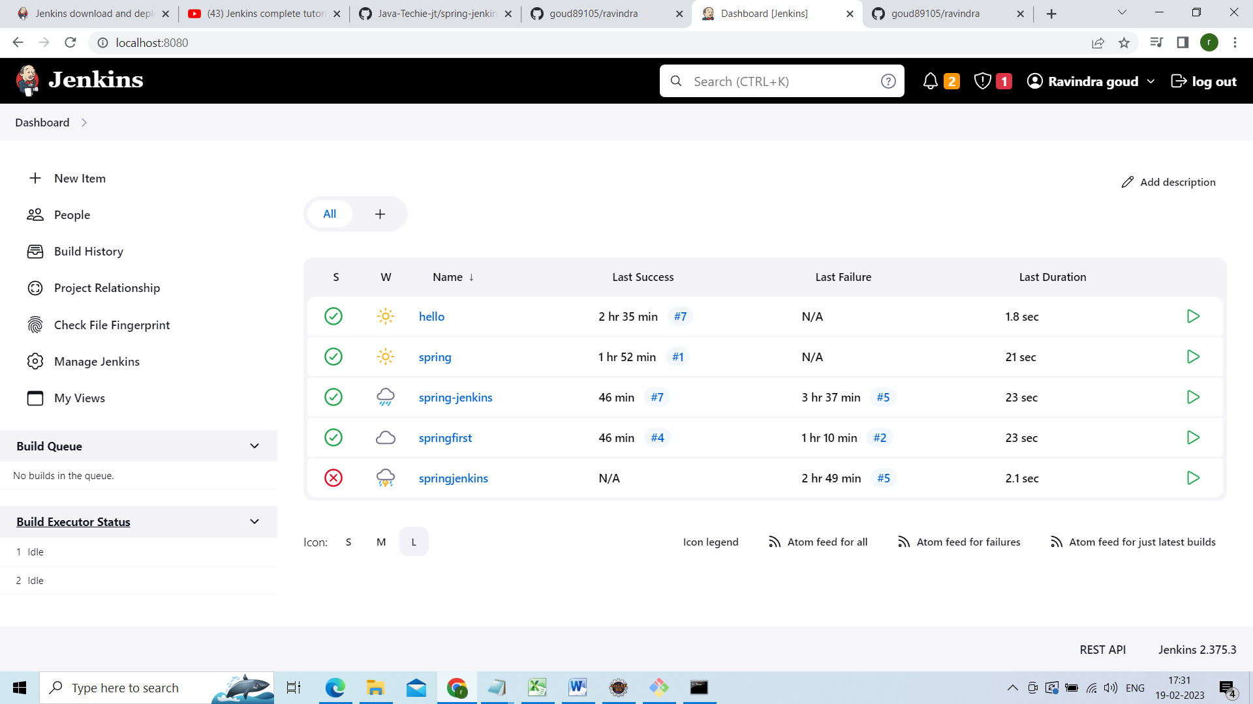

Enter item name as Dev and select Freestyleproject

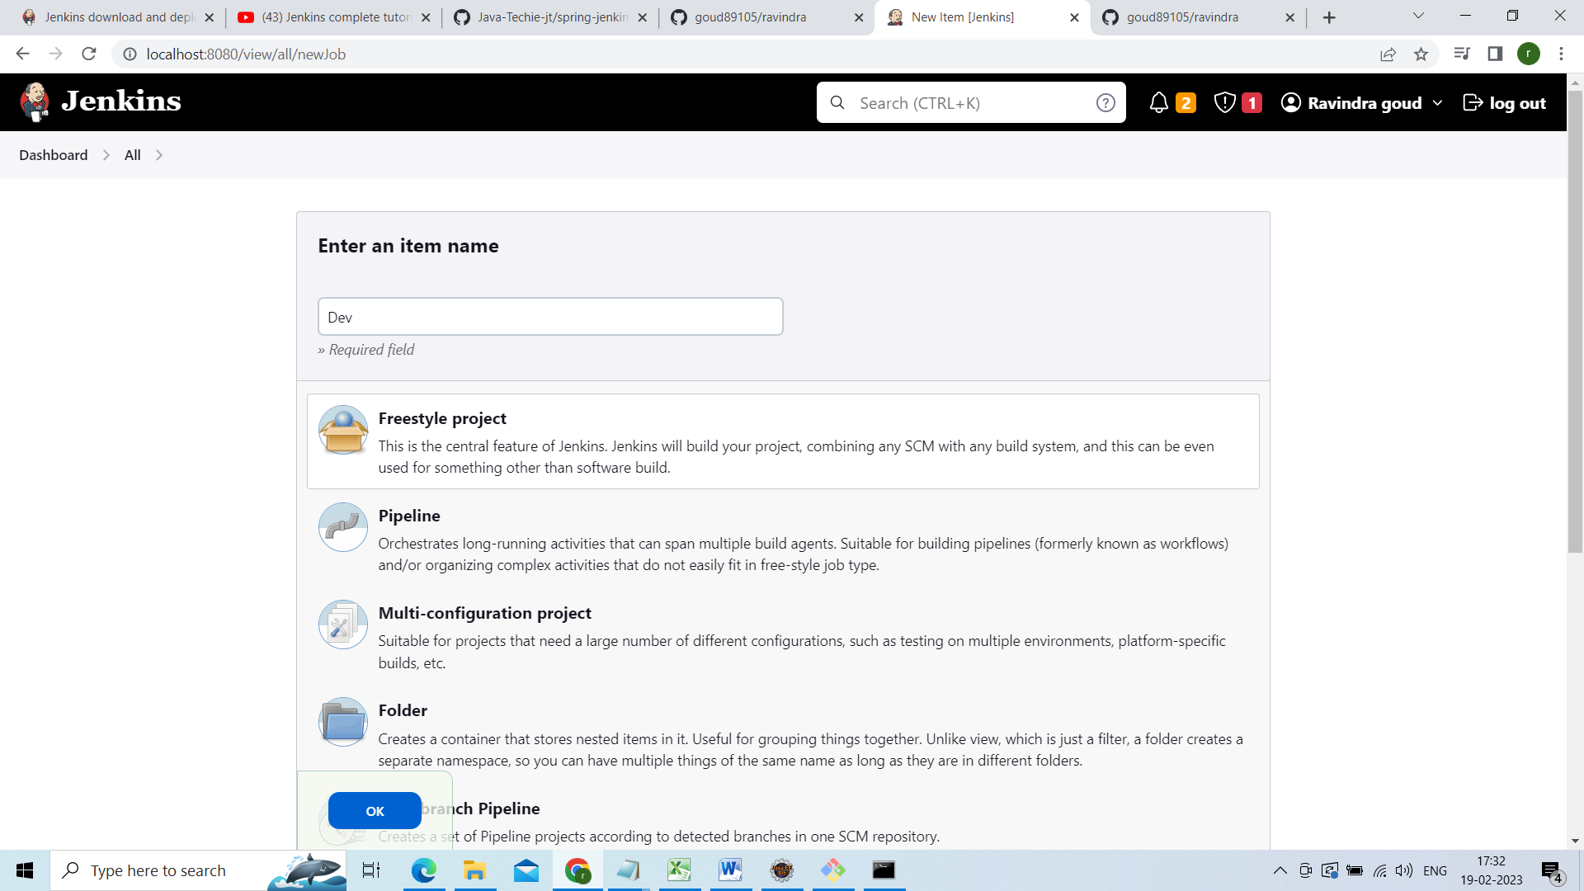

Click ok

Add some description